1. What is React?
React is a front-end and open-source JavaScript library which is useful in developing user interfaces specifically for applications with a single page. It is helpful in building complex and reusable user interface(UI) components of mobile and web applications as it follows the component-based approach.
The important features of React are:
- It supports server-side rendering.
- It will make use of the virtual DOM rather than real DOM (Data Object Model) as RealDOM manipulations are expensive.
- It follows unidirectional data binding or data flow.
- It uses reusable or composable UI components for developing the view.

2. What are the advantages of using React?
MVC is generally abbreviated as Model View Controller.
- Use of Virtual DOM to improve efficiency: React uses virtual DOM to render the view. As the name suggests, virtual DOM is a virtual representation of the real DOM. Each time the data changes in a react app, a new virtual DOM gets created. Creating a virtual DOM is much faster than rendering the UI inside the browser. Therefore, with the use of virtual DOM, the efficiency of the app improves.
- Gentle learning curve: React has a gentle learning curve when compared to frameworks like Angular. Anyone with little knowledge of javascript can start building web applications using React.
- SEO friendly: React allows developers to develop engaging user interfaces that can be easily navigated in various search engines. It also allows server-side rendering, which boosts the SEO of an app.
- Reusable components: React uses component-based architecture for developing applications. Components are independent and reusable bits of code. These components can be shared across various applications having similar functionality. The re-use of components increases the pace of development.
- Huge ecosystem of libraries to choose from: React provides you with the freedom to choose the tools, libraries, and architecture for developing an application based on your requirement.

3. What are the limitations of React?
The few limitations of React are as given below:
- React is not a full-blown framework as it is only a library.
- The components of React are numerous and will take time to fully grasp the benefits of all.
- It might be difficult for beginner programmers to understand React.
- Coding might become complex as it will make use of inline templating and JSX.

4. What is useState() in React?
The useState() is a built-in React Hook that allows you for having state variables in functional components. It should be used when the DOM has something that is dynamically manipulating/controlling.
In the below-given example code, The useState(0) will return a tuple where the count is the first parameter that represents the counter’s current state and the second parameter setCounter method will allow us to update the state of the counter.
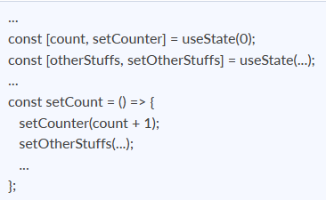
We can make use of setCounter() method for updating the state of count anywhere. In this example, we are using setCounter() inside the setCount function where various other things can also be done. The idea with the usage of hooks is that we will be able to keep our code more functional and avoid class-based components if they are not required.

5. What are keys in React?
A key is a special string attribute that needs to be included when using lists of elements.
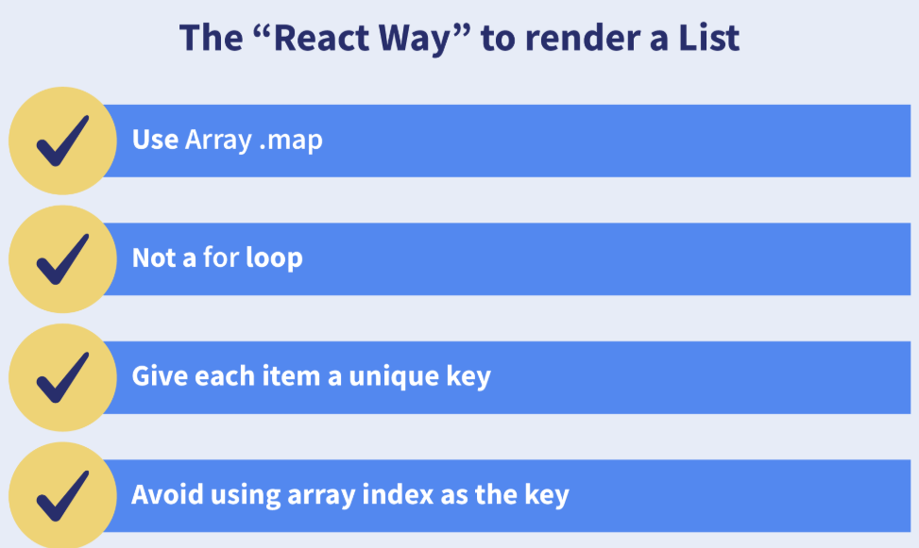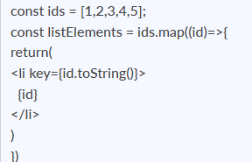
Importance of keys -
- Keys help react identify which elements were added, changed or removed.
- Keys should be given to array elements for providing a unique identity for each element.
- Without keys, React does not understand the order or uniqueness of each element.
- With keys, React has an idea of which particular element was deleted, edited, and added.
- Keys are generally used for displaying a list of data coming from an API.

6. What is JSX?
JSX stands for JavaScript XML. It allows us to write HTML inside JavaScript and place them in the DOM without using functions like appendChild( ) or createElement( ).
As stated in the official docs of React, JSX provides syntactic sugar for React.createElement( ) function.
Note- We can create react applications without using JSX as well.
Let’s understand how JSX works:
Without using JSX, we would have to create an element by the following process:
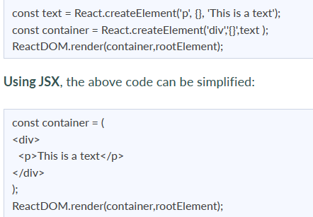

7. What are the differences between functional and class components?
Before the introduction of Hooks in React, functional components were called stateless components and were behind class components on a feature basis. After the introduction of Hooks, functional components are equivalent to class components.
Although functional components are the new trend, the react team insists on keeping class components in React. Therefore, it is important to know how these components differ.
On the following basis let’s compare functional and class components:
Declaration
Functional components are nothing but JavaScript functions and therefore can be declared using an arrow function or the function keyword:
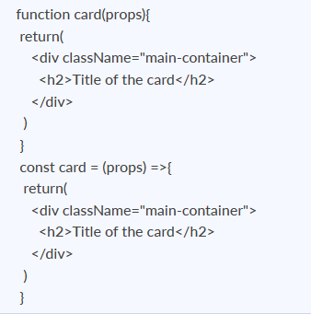
Class components, on the other hand, are declared using the ES6 class:
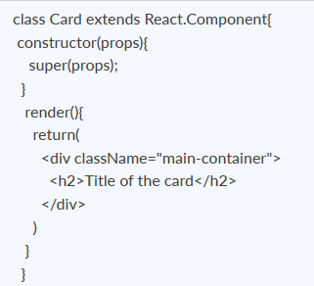
Handling props
Let’s render the following component with props and analyse how functional and class components handle props:
<Student Info name="Vivek" rollNumber="23" />
In functional components, the handling of props is pretty straightforward. Any prop provided as an argument to a functional component can be directly used inside HTML elements:
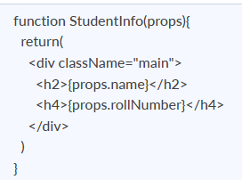
In the case of class components, props are handled in a different way:
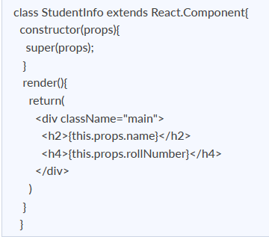
As we can see in the code above, this keyword is used in the case of class components.
Handling state
Functional components use React hooks to handle state. It uses the useState hook to set the state of a variable inside the component:
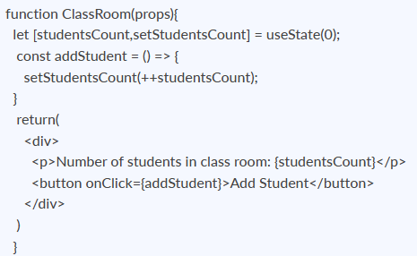
Since useState hook returns an array of two items, the first item contains the current state, and the second item is a function used to update the state.
In the code above, using array destructuring we have set the variable name to studentsCount with a current value of “0” and setStudentsCount is the function that is used to update the state.
For reading the state, we can see from the code above, the variable name can be directly used to read the current state of the variable.
We cannot use React Hooks inside class components, therefore state handling is done very differently in a class component:
Let’s take the same above example and convert it into a class component:
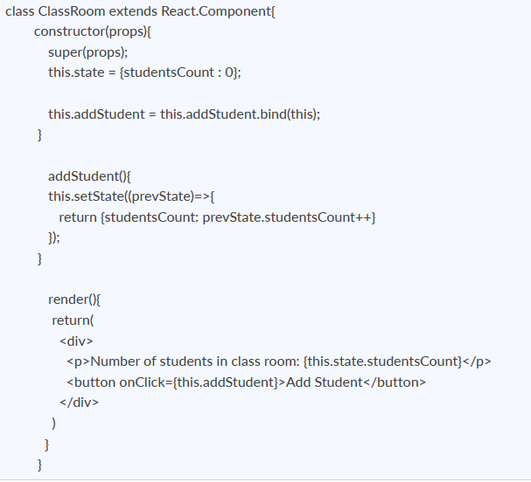
In the code above, we see we are using this.state to add the variable studentsCount and setting the value to “0”.
For reading the state, we are using this.state.studentsCount.
For updating the state, we need to first bind the addStudent function to this. Only then, we will be able to use the setState function which is used to update the state.

8. What is the virtual DOM? How does react use the virtual DOM to render the UI?
As stated by the react team, virtual DOM is a concept where a virtual representation of the real DOM is kept inside the memory and is synced with the real DOM by a library such as ReactDOM.
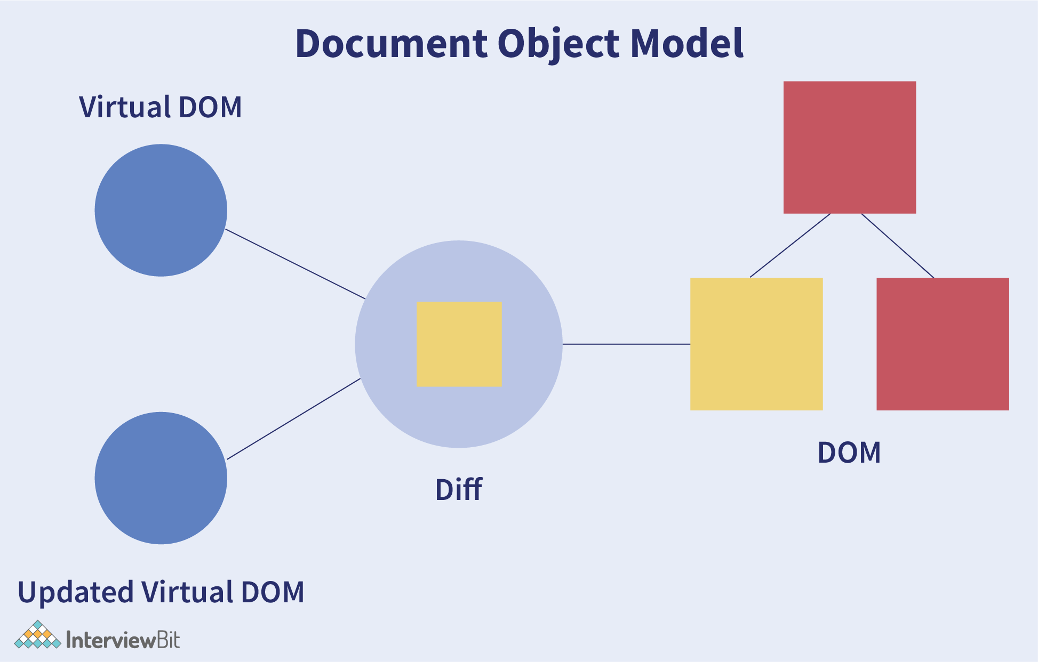
Why was virtual DOM introduced?
DOM manipulation is an integral part of any web application, but DOM manipulation is quite slow when compared to other operations in JavaScript. The efficiency of the application gets affected when several DOM manipulations are being done. Most JavaScript frameworks update the entire DOM even when a small part of the DOM changes.
For example, consider a list that is being rendered inside the DOM. If one of the items in the list changes, the entire list gets rendered again instead of just rendering the item that was changed/updated. This is called inefficient updating.
To address the problem of inefficient updating, the react team introduced the concept of virtual DOM.
How does it work?
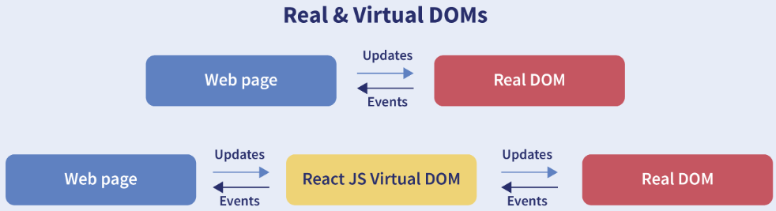
For every DOM object, there is a corresponding virtual DOM object(copy), which has the same properties. The main difference between the real DOM object and the virtual DOM object is that any changes in the virtual DOM object will not reflect on the screen directly. Consider a virtual DOM object as a blueprint of the real DOM object. Whenever a JSX element gets rendered, every virtual DOM object gets updated.
**Note- One may think updating every virtual DOM object might be inefficient, but that’s not the case. Updating the virtual DOM is much faster than updating the real DOM since we are just updating the blueprint of the real DOM.
React uses two virtual DOMs to render the user interface. One of them is used to store the current state of the objects and the other to store the previous state of the objects. Whenever the virtual DOM gets updated, react compares the two virtual DOMs and gets to know about which virtual DOM objects were updated. After knowing which objects were updated, react renders only those objects inside the real DOM instead of rendering the complete real DOM. This way, with the use of virtual DOM, react solves the problem of inefficient updating

9. What are the differences between controlled and uncontrolled components?
Controlled and uncontrolled components are just different approaches to handling input from elements in react.
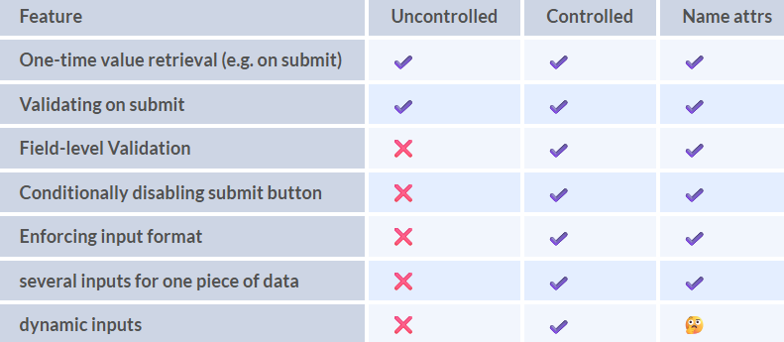
Controlled component: In a controlled component, the value of the input element is controlled by React. We store the state of the input element inside the code, and by using event-based callbacks, any changes made to the input element will be reflected in the code as well.
When a user enters data inside the input element of a controlled component, onChange function gets triggered and inside the code, we check whether the value entered is valid or invalid. If the value is valid, we change the state and re-render the input element with the new value.
Example of a controlled component:
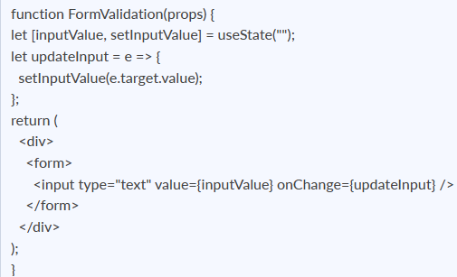
As one can see in the code above, the value of the input element is determined by the state of the inputValue variable. Any changes made to the input element is handled by the updateInput function.
Uncontrolled component: In an uncontrolled component, the value of the input element is handled by the DOM itself. Input elements inside uncontrolled components work just like normal HTML input form elements.
The state of the input element is handled by the DOM. Whenever the value of the input element is changed, event-based callbacks are not called. Basically, react does not perform any action when there are changes made to the input element.
Whenever use enters data inside the input field, the updated data is shown directly. To access the value of the input element, we can use ref.
Example of an uncontrolled component:
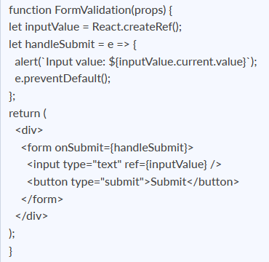

10. What are props in React?
The props in React are the inputs to a component of React. They can be single-valued or objects having a set of values that will be passed to components of React during creation by using a naming convention that almost looks similar to HTML-tag attributes. We can say that props are the data passed from a parent component into a child component.
The main purpose of props is to provide different component functionalities such as:
- Passing custom data to the React component.
- Using through this.props.reactProp inside render() method of the component.
- Triggering state changes.
For example, consider we are creating an element with reactProp property as given below: <Element reactProp = "1" />
This reactProp name will be considered as a property attached to the native props object of React which already exists on each component created with the help of React library: props.reactProp;.

11. Explain React state and props.
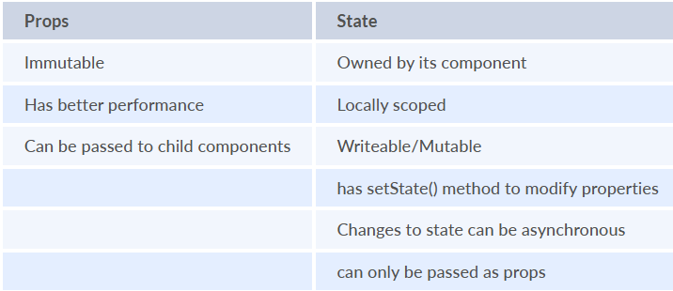
React State
Every component in react has a built-in state object, which contains all the property values that belong to that component.
In other words, the state object controls the behaviour of a component. Any change in the property values of the state object leads to the re-rendering of the component.
Note- State object is not available in functional components but, we can use React Hooks to add state to a functional component.
How to declare a state object?
Example:
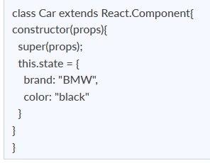
How to use and update the state object?
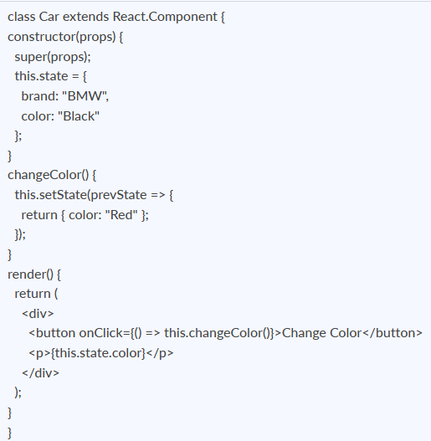
As one can see in the code above, we can use the state by calling this.state.propertyName and we can change the state object property using setState method.
React Props
Every React component accepts a single object argument called props (which stands for “properties”). These props can be passed to a component using HTML attributes and the component accepts these props as an argument.
Using props, we can pass data from one component to another.
Passing props to a component:
While rendering a component, we can pass the props as an HTML attribute:
<Car brand="Mercedes"/>
The component receives the props:
In Class component:
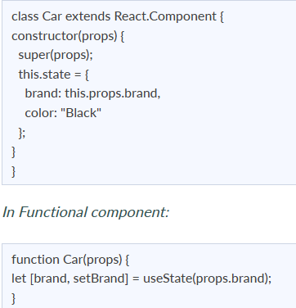

12. Explain about types of side effects in React component.
There are two types of side effects in React component. They are:
- Effects without Cleanup: This side effect will be used in useEffect which does not restrict the browser from screen update. It also improves the responsiveness of an application. A few common examples are network requests, Logging, manual DOM mutations, etc.
- Effects with Cleanup: Some of the Hook effects will require the cleanup after updating of DOM is done. For example, if you want to set up an external data source subscription, it requires cleaning up the memory else there might be a problem of memory leak. It is a known fact that React will carry out the cleanup of memory when the unmounting of components happens. But the effects will run for each render() method rather than for any specific method. Thus we can say that, before execution of the effects succeeding time the React will also cleanup effects from the preceding render.

13. What is prop drilling in React?
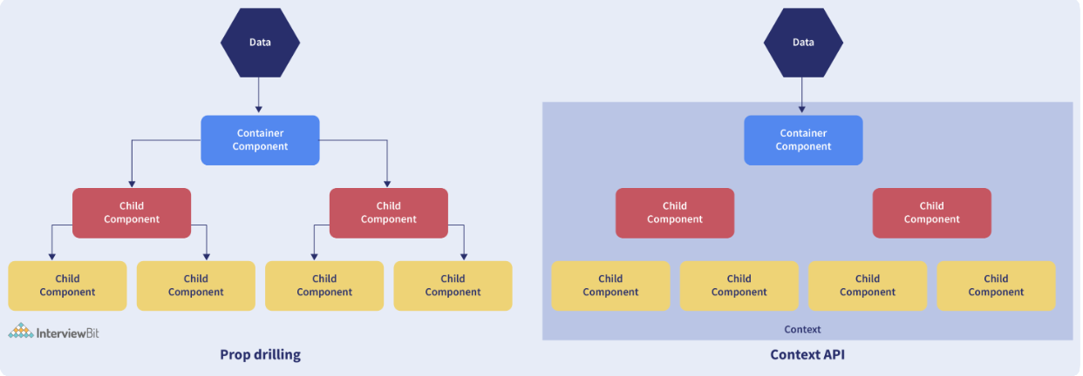
Sometimes while developing React applications, there is a need to pass data from a component that is higher in the hierarchy to a component that is deeply nested. To pass data between such components, we pass props from a source component and keep passing the prop to the next component in the hierarchy till we reach the deeply nested component.
The disadvantage of using prop drilling is that the components that should otherwise be not aware of the data have access to the data.

14. What are error boundaries?
Introduced in version 16 of React, Error boundaries provide a way for us to catch errors that occur in the render phase.
- What is an error boundary?
Any component which uses one of the following lifecycle methods is considered an error boundary.
In what places can an error boundary detect an error?
- Render phase
- Inside a lifecycle method
- Inside the constructor
Without using error boundaries:
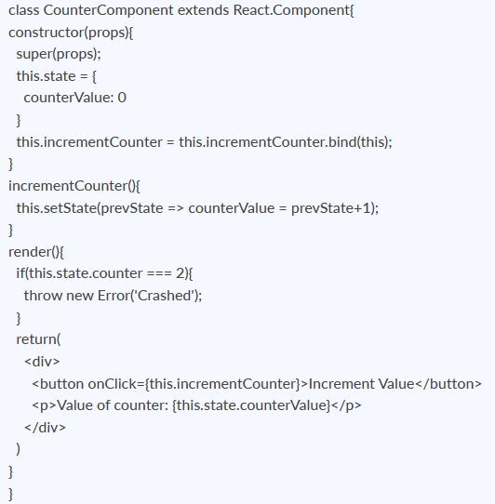
In the code above, when the counterValue equals 2, we throw an error inside the render method.
When we are not using the error boundary, instead of seeing an error, we see a blank page. Since any error inside the render method leads to unmounting of the component. To display an error that occurs inside the render method, we use error boundaries.
With error boundaries: As mentioned above, error boundary is a component using one or both of the following methods: static getDerivedStateFromError and componentDidCatch.
Let’s create an error boundary to handle errors in the render phase:
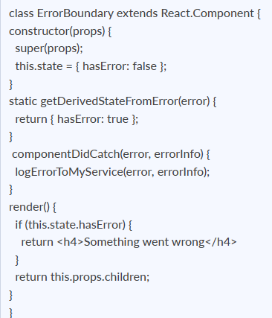
In the code above, getDerivedStateFromError function renders the fallback UI interface when the render method has an error.
componentDidCatch logs the error information to an error tracking service.
Now with the error boundary, we can render the CounterComponent in the following way:
<ErrorBoundary>
<CounterComponent/>
</ErrorBoundary>

15. What is React Hooks?
React Hooks are the built-in functions that permit developers for using the state and lifecycle methods within React components. These are newly added features made available in React 16.8 version. Each lifecycle of a component is having 3 phases which include mount, unmount, and update. Along with that, components have properties and states. Hooks will allow using these methods by developers for improving the reuse of code with higher flexibility navigating the component tree.
Using Hook, all features of React can be used without writing class components. For example, before React version 16.8, it required a class component for managing the state of a component. But now using the useState hook, we can keep the state in a functional component.

16. Explain React Hooks.
What are Hooks? Hooks are functions that let us “hook into” React state and lifecycle features from a functional component.
React Hooks cannot be used in class components. They let us write components without class.
Why were Hooks introduced in React?
React hooks were introduced in the 16.8 version of React. Previously, functional components were called stateless components. Only class components were used for state management and lifecycle methods. The need to change a functional component to a class component, whenever state management or lifecycle methods were to be used, led to the development of Hooks.
Example of a hook: useState hook:
In functional components, the useState hook lets us define a state for a component:
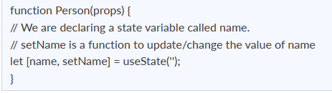
The state variable “name” can be directly used inside the HTML.

17. What are the rules that must be followed while using React Hooks?
There are 2 rules which must be followed while you code with Hooks:
- React Hooks must be called only at the top level. It is not allowed to call them inside the nested functions, loops, or conditions.
- It is allowed to call the Hooks only from the React Function Components.

18. What is the use of useEffect React Hooks?
The useEffect React Hook is used for performing the side effects in functional components. With the help of useEffect, you will inform React that your component requires something to be done after rendering the component or after a state change. The function you have passed(can be referred to as “effect”) will be remembered by React and call afterwards the performance of DOM updates is over. Using this, we can perform various calculations such as data fetching, setting up document title, manipulating DOM directly, etc, that don’t target the output value. The useEffect hook will run by default after the first render and also after each update of the component. React will guarantee that the DOM will be updated by the time when the effect has run by it.
The useEffect React Hook will accept 2 arguments: useEffect(callback,[dependencies]);
Where the first argument callback represents the function having the logic of side-effect and it will be immediately executed after changes were being pushed to DOM. The second argument dependencies represent an optional array of dependencies. The useEffect() will execute the callback only if there is a change in dependencies in between renderings.
Example:
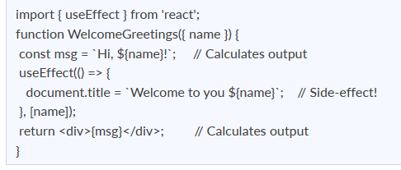
The above code will update the document title which is considered to be a side-effect as it will not calculate the component output directly. That is why updating of document title has been placed in a callback and provided to useEffect().
Consider you don’t want to execute document title update each time on rendering of WelcomeGreetings component and you want it to be executed only when the name prop changes then you need to supply name as a dependency to useEffect(callback, [name]).

19. Why do React Hooks make use of refs?
Earlier, refs were only limited to class components but now it can also be accessible in function components through the useRef Hook in React.
The refs are used for:
- Managing focus, media playback, or text selection.
- Integrating with DOM libraries by third-party.
- Triggering the imperative animations.

20. What are Custom Hooks?
A Custom Hook is a function in Javascript whose name begins with ‘use’ and which calls other hooks. It is a part of React v16.8 hook update and permits you for reusing the stateful logic without any need for component hierarchy restructuring.
In almost all of the cases, custom hooks are considered to be sufficient for replacing render props and HoCs (Higher-Order components) and reducing the amount of nesting required. Custom Hooks will allow you for avoiding multiple layers of abstraction or wrapper hell that might come along with Render Props and HoCs.
The disadvantage of Custom Hooks is it cannot be used inside of the classes.

21. How to create a switching component for displaying different pages?
A switching component refers to a component that will render one of the multiple components. We should use an object for mapping prop values to components.
A below-given example will show you how to display different pages based on page prop using switching component:
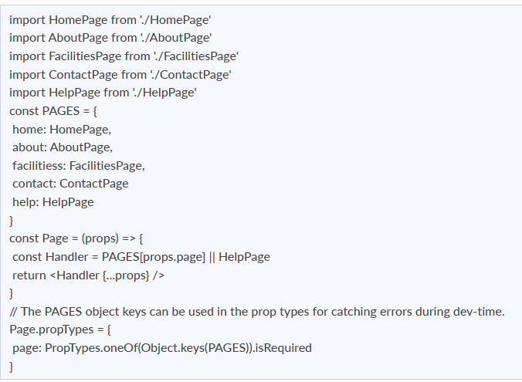

22. How to re-render the view when the browser is resized?
It is possible to listen to the resize event in componentDidMount() and then update the width and height dimensions. It requires the removal of the event listener in the componentWillUnmount() method.
Using the below-given code, we can render the view when the browser is resized.
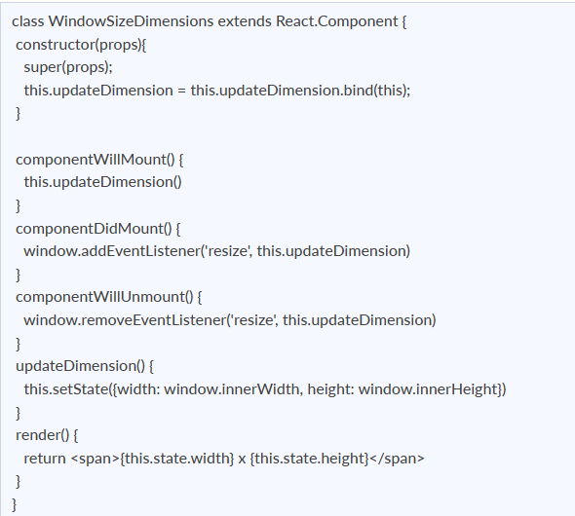

23. How to pass data between sibling components using React router?
Passing data between sibling components of React is possible using React Router with the help of history.push and match.params.
In the code given below, we have a Parent component AppDemo.js and have two Child Components HomePage and AboutPage. Everything is kept inside a Router by using React-router Route. It is also having a route for /about/{params} where we will pass the data.
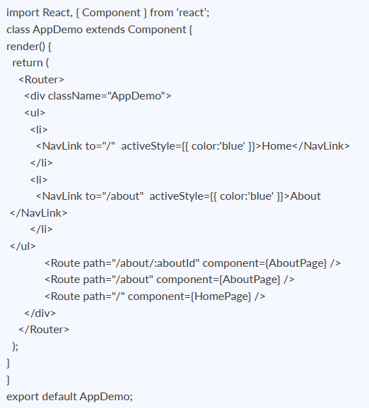
The HomePage is a functional component with a button. On button click, we are using props.history.push(‘/about/’ + data) to programmatically navigate into /about/data.
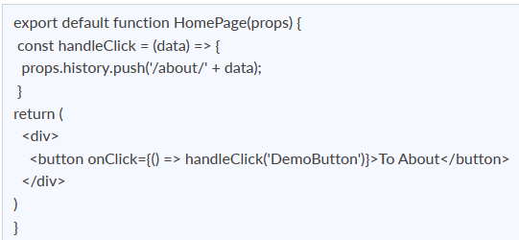
Also, the functional component AboutPage will obtain the data passed by props.match.params.aboutId.
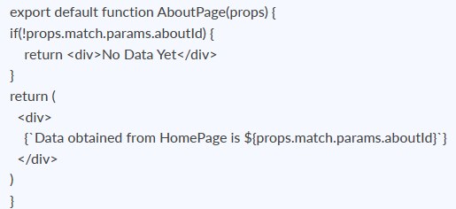

24. How to perform automatic redirect after login?
The react-router package will provide the component <Redirect> in React Router. Rendering of a <Redirect> component will navigate to a newer location. In the history stack, the current location will be overridden by the new location just like the server-side redirects.
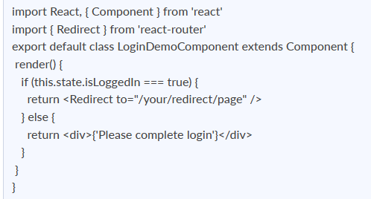

25. Does React Hook work with static typing?
Static typing refers to the process of code check during the time of compilation for ensuring all variables will be statically typed. React Hooks are functions that are designed to make sure about all attributes must be statically typed. For enforcing stricter static typing within our code, we can make use of the React API with custom Hooks.

26. Explain Strict Mode in React.
StrictMode is a tool added in version 16.3 of React to highlight potential problems in an application. It performs additional checks on the application.
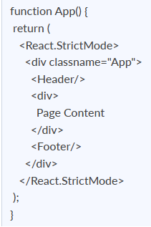
To enable StrictMode, <React.StrictMode> tags need to be added inside the application:
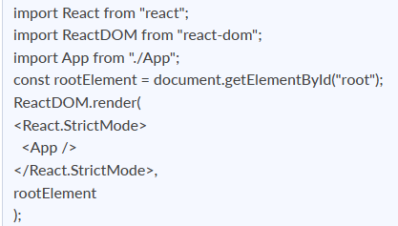
StrictMode currently helps with the following issues:
- Identifying components with unsafe lifecycle methods:
  - Certain lifecycle methods are unsafe to use in asynchronous react applications. With the use of third-party libraries, it becomes difficult to ensure that certain lifecycle methods are not used.
  - StrictMode helps in providing us with a warning if any of the class components use an unsafe lifecycle method.
- Warning about the usage of legacy string API:
  - If one is using an older version of React, callback ref is the recommended way to manage refs instead of using the string refs. StrictMode gives a warning if we are using string refs to manage refs.
- Warning about the usage of findDOMNode:
  - Previously, findDOMNode( ) method was used to search the tree of a DOM node. This method is deprecated in React. Hence, the StrictMode gives us a warning about the usage of this method.
- Warning about the usage of legacy context API (because the API is error-prone).

27. How to prevent re-renders in React?
- Reason for re-renders in React:
  - Re-rendering of a component and its child components occur when props or the state of the component has been changed.
  - Re-rendering components that are not updated, affects the performance of an application.
- How to prevent re-rendering:
Consider the following components:
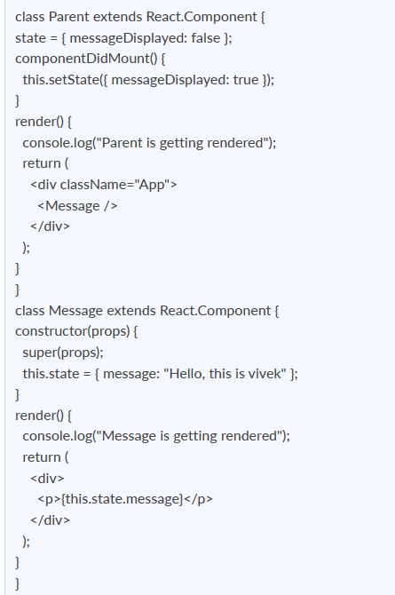
- The Parent component is the parent component and the Message is the child component. Any change in the parent component will lead to re-rendering of the child component as well. To prevent the re-rendering of child components, we use the shouldComponentUpdate( ) method:
**Note- Use shouldComponentUpdate( ) method only when you are sure that it’s a static component.
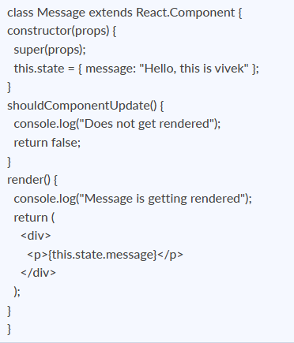

28. What are the different ways to style a React component?
There are many different ways through which one can style a React component. Some of the ways are :
- Inline Styling: We can directly style an element using inline style attributes. Make sure the value of style is a JavaScript object:
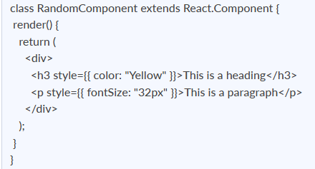
- Using JavaScript object: We can create a separate JavaScript object and set the desired style properties. This object can be used as the value of the inline style attribute.
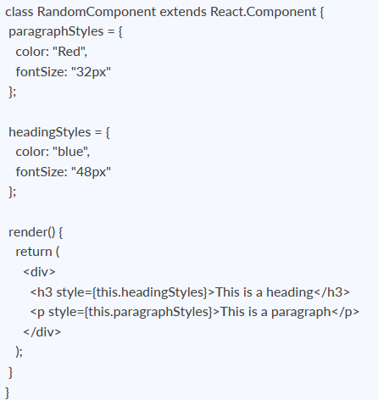
- CSS Stylesheet: We can create a separate CSS file and write all the styles for the component inside that file. This file needs to be imported inside the component file.
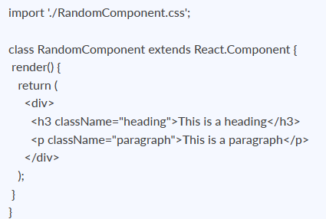
- CSS Modules: We can create a separate CSS module and import this module inside our component. Create a file with “.module.css”‘ extension, styles.module.css:
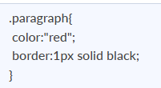
We can import this file inside the component and use it:
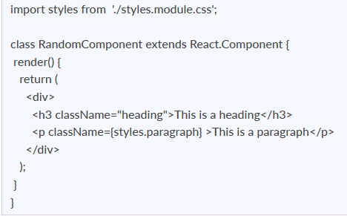

29. Name a few techniques to optimize React app performance.
There are many ways through which one can optimize the performance of a React app, let’s have a look at some of them:
- Using useMemo( ) -
  - It is a React hook that is used for caching CPU-Expensive functions.
  - Sometimes in a React app, a CPU-Expensive function gets called repeatedly due to re-renders of a component, which can lead to slow rendering.
useMemo( ) hook can be used to cache such functions. By using useMemo( ), the CPU-Expensive function gets called only when it is needed.
- Using React.PureComponent -
  - It is a base component class that checks the state and props of a component to know whether the component should be updated.
  - Instead of using the simple React.Component, we can use React.PureComponent to reduce the re-renders of a component unnecessarily.
- Maintaining State Colocation -
  - This is a process of moving the state as close to where you need it as possible.
  - Sometimes in React app, we have a lot of unnecessary states inside the parent component which makes the code less readable and harder to maintain. Not to forget, having many states inside a single component leads to unnecessary re-renders for the component.
  - It is better to shift states which are less valuable to the parent component, to a separate component.
- Lazy Loading -
  - It is a technique used to reduce the load time of a React app. Lazy loading helps reduce the risk of web app performances to a minimum.

30. How to pass data between react components?

Parent Component to Child Component (using props)
With the help of props, we can send data from a parent to a child component.
How do we do this?
Consider the following Parent Component:
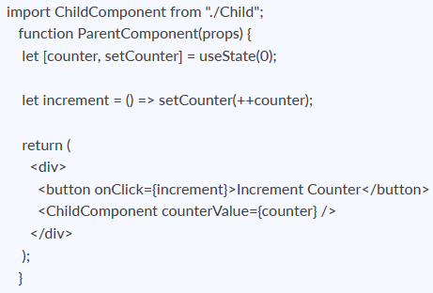
As one can see in the code above, we are rendering the child component inside the parent component, by providing a prop called counterValue. The value of the counter is being passed from the parent to the child component.
We can use the data passed by the parent component in the following way:
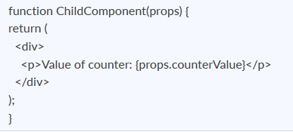
We use the props.counterValue to display the data passed on by the parent component.
Child Component to Parent Component (using callbacks)
This one is a bit tricky. We follow the steps below:
- Create a callback in the parent component which takes in the data needed as a parameter.
- Pass this callback as a prop to the child component.
- Send data from the child component using the callback.
We are considering the same example above but in this case, we are going to pass the updated counterValue from child to parent.
Step1 and Step2: Create a callback in the parent component, pass this callback as a prop.
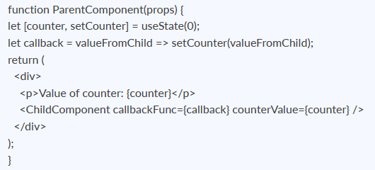
As one can see in the code above, we created a function called callback which takes in the data received from the child component as a parameter.
Next, we passed the function callback as a prop to the child component.
Step3: Pass data from the child to the parent component.
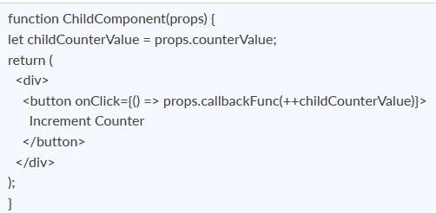
In the code above, we have used the props.counterValue and set it to a variable called childCounterValue.
Next, on button click, we pass the incremented childCounterValue to the props.callbackFunc.
This way, we can pass data from the child to the parent component.

31. What are Higher Order Components?
Simply put, Higher-Order Component(HOC) is a function that takes in a component and returns a new component.
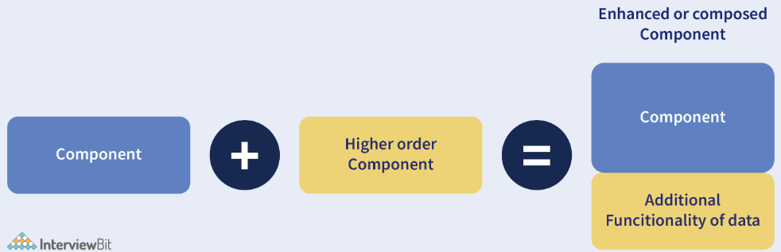
When do we need a Higher Order Component?
While developing React applications, we might develop components that are quite similar to each other with minute differences. In most cases, developing similar components might not be an issue but, while developing larger applications we need to keep our code DRY, therefore, we want an abstraction that allows us to define this logic in a single place and share it across components. HOC allows us to create that abstraction.
Example of a HOC:
Consider the following components having similar functionality. The following component displays the list of articles:
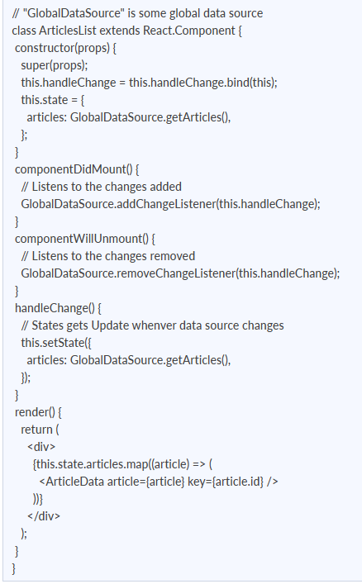
The following component displays the list of users:
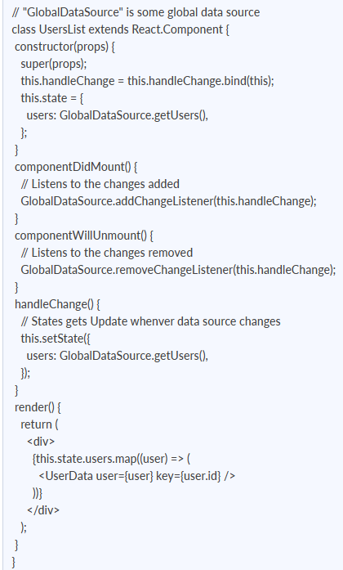
Notice the above components, both have similar functionality but, they are calling different methods to an API endpoint.
Let’s create a Higher Order Component to create an abstraction:
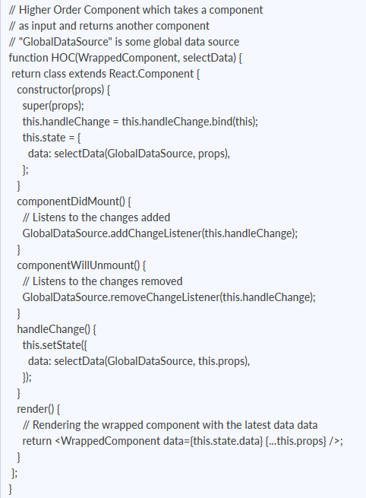
We know HOC is a function that takes in a component and returns a component.
In the code above, we have created a function called HOC which returns a component and performs functionality that can be shared across both the ArticlesList component and UsersList Component.
The second parameter in the HOC function is the function that calls the method on the API endpoint.
We have reduced the duplicated code of the componentDidUpdate and componentDidMount functions.
Using the concept of Higher-Order Components, we can now render the ArticlesList and UsersList components in the following way:
const ArticlesListWithHOC = HOC(ArticlesList, (GlobalDataSource) => GlobalDataSource.getArticles());
const UsersListWithHOC = HOC(UsersList, (GlobalDataSource) => GlobalDataSource.getUsers());
Remember, we are not trying to change the functionality of each component, we are trying to share a single functionality across multiple components using HOC.

32. What are the different phases of the component lifecycle?
There are four different phases in the lifecycle of React component. They are:
- Initialization: During this phase, React component will prepare by setting up the default props and initial state for the upcoming tough journey.
- Mounting: Mounting refers to putting the elements into the browser DOM. Since React uses VirtualDOM, the entire browser DOM which has been currently rendered would not be refreshed. This phase includes the lifecycle methods componentWillMount and componentDidMount.
- Updating: In this phase, a component will be updated when there is a change in the state or props of a component. This phase will have lifecycle methods like componentWillUpdate, shouldComponentUpdate, render, and componentDidUpdate.
- Unmounting: In this last phase of the component lifecycle, the component will be removed from the DOM or will be unmounted from the browser DOM. This phase will have the lifecycle method named componentWillUnmount.
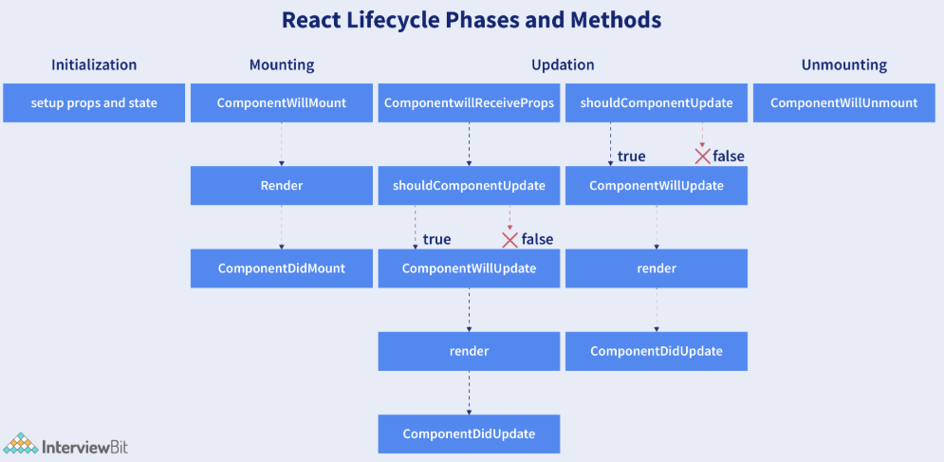

33. What are the lifecycle methods of React?
React lifecycle hooks will have the methods that will be automatically called at different phases in the component lifecycle and thus it provides good control over what happens at the invoked point. It provides the power to effectively control and manipulate what goes on throughout the component lifecycle.
For example, if you are developing the YouTube application, then the application will make use of a network for buffering the videos and it consumes the power of the battery (assume only these two). After playing the video if the user switches to any other application, then you should make sure that the resources like network and battery are being used most efficiently. You can stop or pause the video buffering which in turn stops the battery and network usage when the user switches to another application after video play.
So we can say that the developer will be able to produce a quality application with the help of lifecycle methods and it also helps developers to make sure to plan what and how to do it at different points of birth, growth, or death of user interfaces.
The various lifecycle methods are:
- constructor(): This method will be called when the component is initiated before anything has been done. It helps to set up the initial state and initial values.
- getDerivedStateFromProps(): This method will be called just before element(s) rendering in the DOM. It helps to set up the state object depending on the initial props. The getDerivedStateFromProps() method will have a state as an argument and it returns an object that made changes to the state. This will be the first method to be called on an updating of a component.
- render(): This method will output or re-render the HTML to the DOM with new changes. The render() method is an essential method and will be called always while the remaining methods are optional and will be called only if they are defined.
- componentDidMount(): This method will be called after the rendering of the component. Using this method, you can run statements that need the component to be already kept in the DOM.
- shouldComponentUpdate(): The Boolean value will be returned by this method which will specify whether React should proceed further with the rendering or not. The default value for this method will be True.
- getSnapshotBeforeUpdate(): This method will provide access for the props as well as for the state before the update. It is possible to check the previously present value before the update, even after the update.
- componentDidUpdate(): This method will be called after the component has been updated in the DOM.
- componentWillUnmount(): This method will be called when the component removal from the DOM is about to happen.

34. Explain how to create a simple React Hooks example program.
I will assume that you are having some coding knowledge about JavaScript and have installed Node on your system for creating a below given React Hook program. An installation of Node comes along with the command-line tools: npm and npx, where npm is useful to install the packages into a project and npx is useful in running commands of Node from the command line. The npx looks in the current project folder for checking whether a command has been installed there. When the command is not available on your computer, the npx will look in the npmjs.com repository, then the latest version of the command script will be loaded and will run without locally installing it. This feature is useful in creating a skeleton React application within a few key presses.
Open the Terminal inside the folder of your choice, and run the following command:
npx create-react-app react-items-with-hooks
Here, the create-react-app is an app initializer created by Facebook, to help with the easy and quick creation of React application, providing options to customize it while creating the application? The above command will create a new folder named react-items-with-hooks and it will be initialized with a basic React application. Now, you will be able to open the project in your favourite IDE. You can see an src folder inside the project along with the main application component App.js. This file is having a single function App() which will return an element and it will make use of an extended JavaScript syntax(JSX) for defining the component.
JSX will permit you for writing HTML-style template syntax directly into the JavaScript file. This mixture of JavaScript and HTML will be converted by React toolchain into pure JavaScript that will render the HTML element.
It is possible to define your own React components by writing a function that will return a JSX element. You can try this by creating a new file src/SearchItem.jsand put the following code into it.
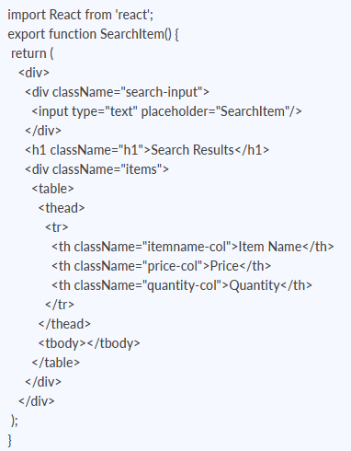
This is all about how you can create a component. It will only display the empty table and doesn’t do anything. But you will be able to use the Search component in the application. Open the file src/App.js and add the import statement given below to the top of the file.
import { SearchItem } from './SearchItem';
Now, from the logo.svg, import will be removed and then contents of returned value in the function App() will be replaced with the following code:
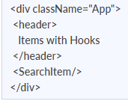
You can notice that the element <SearchItem/> has been used just similar to an HTML element. The JSX syntax will enable for including the components in this approach directly within the JavaScript code. Your application can be tested by running the below-given command in your terminal.
npm start
This command will compile your application and open your default browser into http://localhost:4000. This command can be kept on running when code development is in progress to make sure that the application is up-to-date, and also this browser page will be reloaded each time you modify and save the code.
This application will work finely, but it doesn’t look nice as it doesn’t react to any input from the user. You can make it more interactive by adding a state with React Hooks, adding authentication, etc.

35. Explain about types of Hooks in React.
There are two types of Hooks in React. They are:
1. Built-in Hooks: The built-in Hooks are divided into 2 parts as given below:
- Basic Hooks:
  - useState(): This functional component is used to set and retrieve the state.
  - useEffect(): It enables for performing the side effects in the functional components.
  - useContext(): It is used for creating common data that is to be accessed by the components hierarchy without having to pass the props down to each level.
- Additional Hooks:
  - useReducer() : It is used when there is a complex state logic that is having several sub-values or when the upcoming state is dependent on the previous state. It will also enable you to optimization of component performance that will trigger deeper updates as it is permitted to pass the dispatch down instead of callbacks.
  - useMemo() : This will be used for recomputing the memoized value when there is a change in one of the dependencies. This optimization will help for avoiding expensive calculations on each render.
  - useCallback() : This is useful while passing callbacks into the optimized child components and depends on the equality of reference for the prevention of unneeded renders.
  - useImperativeHandle(): It will enable modifying the instance that will be passed with the ref object.
  - useDebugValue(): It is used for displaying a label for custom hooks in React DevTools.
  - useRef() : It will permit creating a reference to the DOM element directly within the functional component.
  - useLayoutEffect(): It is used for the reading layout from the DOM and re-rendering synchronously.
2. Custom Hooks: A custom Hook is basically a function of JavaScript. The Custom Hook working is similar to a regular function. The “use” at the beginning of the Custom Hook Name is required for React to understand that this is a custom Hook and also it will describe that this specific function follows the rules of Hooks. Moreover, developing custom Hooks will enable you for extracting component logic from within reusable functions.
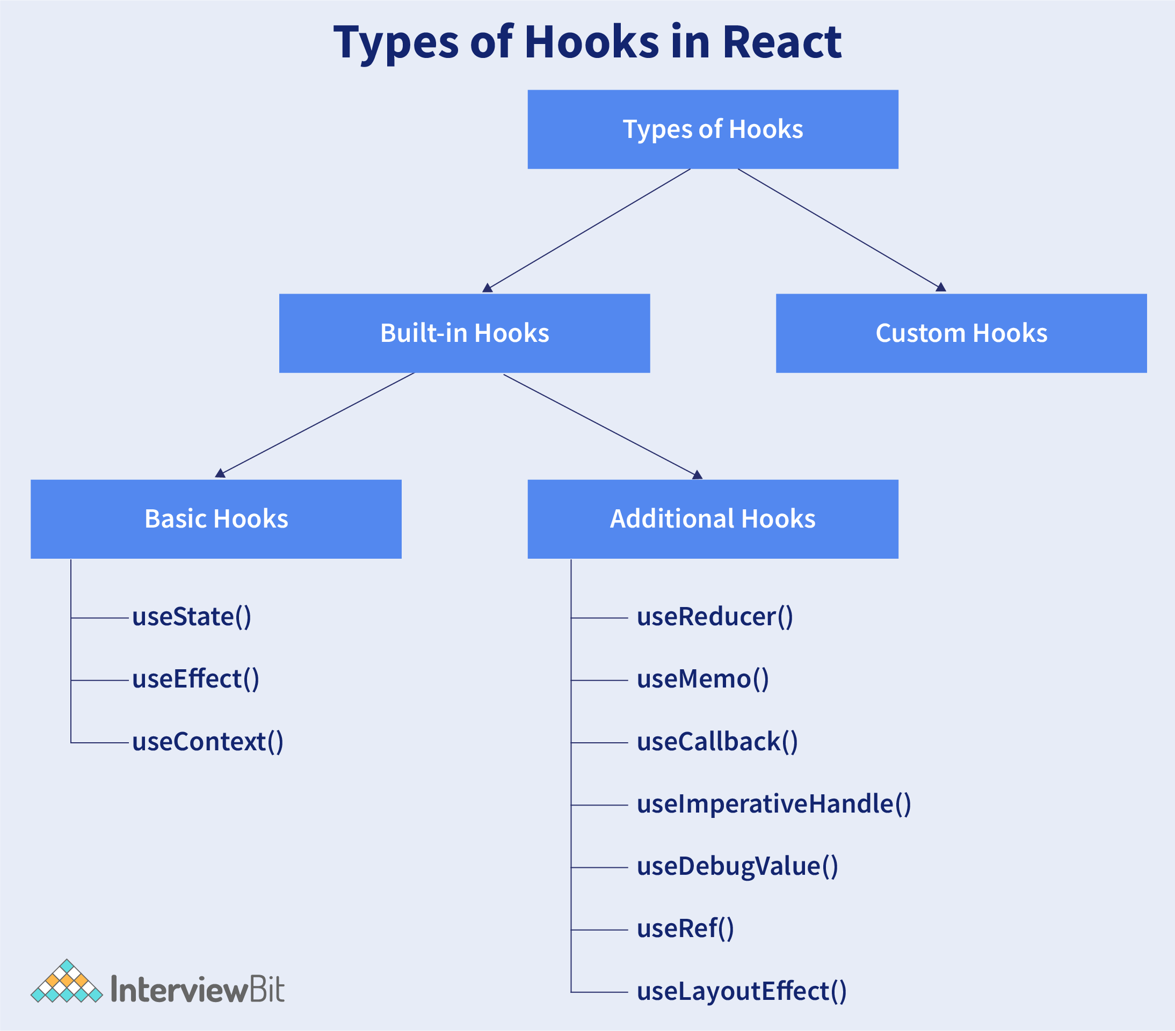

36. Differentiate React Hooks vs Classes.
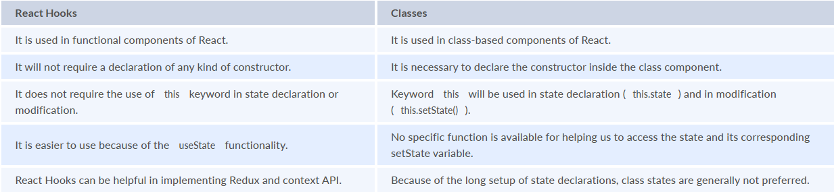

37. How does the performance of using Hooks will differ in comparison with the classes?
- React Hooks will avoid a lot of overheads such as the instance creation, binding of events, etc., that are present with classes.
- Hooks in React will result in smaller component trees since they will be avoiding the nesting that exists in HOCs (Higher Order Components) and will render props which result in less amount of work to be done by React.

38. Do Hooks cover all the functionalities provided by the classes?
Our goal is for Hooks to cover all the functionalities for classes at its earliest. There are no Hook equivalents for the following methods that are not introduced in Hooks yet:
- getSnapshotBeforeUpdate()
- getDerivedStateFromError()
- componentDidCatch()
Since it is an early time for Hooks, few third-party libraries may not be compatible with Hooks at present, but they will be added soon.

39. What is React Router?
React Router refers to the standard library used for routing in React. It permits us for building a single-page web application in React with navigation without even refreshing the page when the user navigates. It also allows to change the browser URL and will keep the user interface in sync with the URL. React Router will make use of the component structure for calling the components, using which appropriate information can be shown. Since React is a component-based framework, it’s not necessary to include and use this package. Any other compatible routing library would also work with React.
The major components of React Router are given below:
- BrowserRouter: It is a router implementation that will make use of the HTML5 history API (pushState, popstate, and event replaceState) for keeping your UI to be in sync with the URL. It is the parent component useful in storing all other components.
- Routes: It is a newer component that has been introduced in the React v6 and an upgrade of the component.
- Route: It is considered to be a conditionally shown component and some UI will be rendered by this whenever there is a match between its path and the current URL.
- Link: It is useful in creating links to various routes and implementing navigation all over the application. It works similarly to the anchor tag in HTML.

40. Can React Hook replaces Redux?
The React Hook cannot be considered as a replacement for Redux (It is an open-source, JavaScript library useful in managing the application state) when it comes to the management of the global application state tree in large complex applications, even though the React will provide a useReducer hook that manages state transitions similar to Redux. Redux is very useful at a lower level of component hierarchy to handle the pieces of a state which are dependent on each other, instead of a declaration of multiple useState hooks.
In commercial web applications which is larger, the complexity will be high, so using only React Hook may not be sufficient. Few developers will try to tackle the challenge with the help of React Hooks and others will combine React Hooks with the Redux.

41. Explain conditional rendering in React.
Conditional rendering refers to the dynamic output of user interface markups based on a condition state. It works in the same way as JavaScript conditions. Using conditional rendering, it is possible to toggle specific application functions, API data rendering, hide or show elements, decide permission levels, authentication handling, and so on.
There are different approaches for implementing conditional rendering in React. Some of them are:
- Using if-else conditional logic which is suitable for smaller as well as for medium-sized applications
- Using ternary operators, which takes away some amount of complication from if-else statements
- Using element variables, which will enable us to write cleaner code.

42. What is reconciliation? How does React's diffing algorithm work?
So this concept is not very difficult once you read its rules and uses!
What you should do here is get familiar with the concept right now, have a read, and then, in the end, I’ll mention a short answer-like paragraph that you can use during your interview.
So to understand Reconciliation:
Reconciliation is the internal algo process React uses to compare the previous Virtual DOM tree with the newly generated Virtual DOM tree after a state or prop changes.
Here’s what happens to make it work:
- React re-renders the component to produce a new Virtual DOM tree
- It compares this tree with the previous Virtual DOM tree
- It computes a set of changes called mutations
- It applies only those changes to the real DOM
And so, this process is used to avoid unnecessary DOM operations, which end up being expensive.
Coming to React’s Diffing Algorithm -
React’s Diffing Algorithm is a part of the reconciliation process, where its primary goal is to minimize DOM updates.
Now it is important to understand how this takes place, so please look into this carefully:
- The expensive but optimal component is (O(n3 ) )
- React uses a tree-diffing algorithm to minimize DOM
- Hence, it uses a heuristic O(n) algorithm instead of specific assumptions
What it essentially does is compare root elements, then if they differ, the entire subtree is replaced, and if they match, then its attributes and the recursion on children are compared.
There are some rules of diffing that you really need to keep in mind:
1. Different trees are produced because of different elements
If the root elements have different types, React:
- unmounts the old component tree,
- destroys associated DOM nodes,
- mounts a new tree.
Example:
<div /> → <section />
This triggers a full rebuild of that subtree.
2. Elements of the same type are compared attribute-wise
If element types are the same, React updates only the changed attributes, and then recursively compares child elements
3. Keys are used to match children in lists
When reconciling lists, React uses the key prop to identify which items have stayed the same, moved, or have been added or removed
For eg:
items.map(item => <li key={item.id}>{item.name}</li>)
There is a reason why these keys are critical:
- They provide a stable identity across renders
- Prevent incorrect reuse of DOM nodes
- Preserve component state
Without stable keys, React falls back to index-based matching
What you must also note is that Reordering can lead to state being assigned to the wrong component, unnecessary re-renders, and even UI inconsistencies.
You must be wondering why the complexity is O(n) instead of O(n³) -
A full tree comparison would require checking every node against every other node, which then results in O(n³) complexity.
React reduces this to O(n) using two assumptions:
- Different element types produce different subtrees - Because of this, there is no need to deeply compare and replace directly
- Keys uniquely identify elements in lists - Enables efficient matching of children without exhaustive comparison
These heuristics make React perform reconciliation in linear time relative to the number of elements.
Now this was all you needed to know about reconciliation,
Here’s a short answer that you can prepare if the interviewer isn’t expecting anything detailed:
- Reconciliation is the process by which React compares the previous and new Virtual DOM trees to compute the minimal DOM updates. It uses a heuristic O(n) diffing algorithm based on two assumptions: elements of different types produce different trees, and keys provide a stable identity for list elements.
Now you are good to go!

43. What is forwardRef, and when do you need it?
This one is simple!
You can use forwardRef to pass a ref from the parent component through the child component to a DOM element or another component inside it.
You need it particularly because, by default, function components do not accept ref, as ref is not a regular prop, and it is handled separately by React.
forwardRef is needed because it enables access to a child component’s DOM node, it helps in imperative actions like
.focus()
,
.scrollIntoView()
, and measuring layout.
So, when you don’t use forwardRef, the parent won’t be able to directly interact with the child’s internal DOM elements, and hence it may hinder when required to reuse.
This is how forwardRef works -
React.forwardRef wraps a functional component and provides ref as a second argument.
This is the pattern:
const Input = React.forwardRef((props, ref) => {
return <input ref={ref} {...props} />;
});
Here’s how you can use it:
const inputRef = useRef();
<Input ref={inputRef} />
Now the parent can directly call:
inputRef.current.focus();
Some common use cases are - integrating DOM libraries, focus management, triggering animations, measuring DOM elements, etc.

44. What is server-side rendering (SSR)? How does it differ from client-side rendering?
With server-side rendering, i.e, SSR, you don’t have to entirely build the UI in the browser; instead of that, it helps by generating the HTML on the server for each request and sending it to the browser.
After the HTML is delivered, the browser displays content immediately, and React then hydrates the page to make it interactive.
You can be asked the difference between Client-side-rendering and server-side rendering, so here are some points that you can keep in mind:
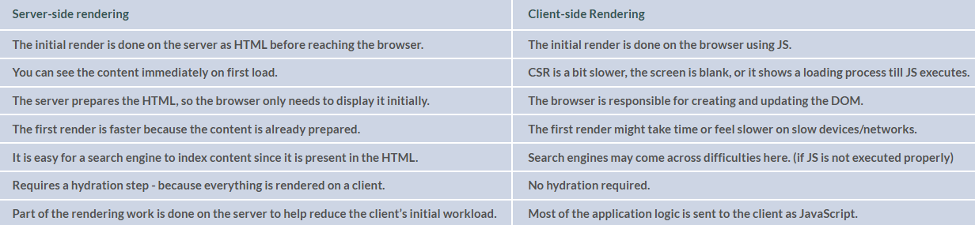
To quickly understand the advantages of SSR:
- It has a faster initial load time,
- Better SEO
- And improved perceived performance
Now, here are some things you need to look out for,
It has a higher server load, complex infrastructure, and hydration mismatch issues, sometimes even a slight delay before full interactivity.
You can also be asked questions like, " What is hydration? In the interviews, so here’s how you can answer -
Hydration is the process by which React attaches event listeners and restores component state on top of the server-rendered HTML.
- It converts static HTML into a fully interactive React app
- Must match the server-rendered output to avoid errors
You should also note some modern approaches made by React:
1. Frameworks like Next.js provide built-in SSR support, which helps in mixing SSR, CSR, and SSG.
2. Static Site Generation (SSG), here pages are pre-rendered at build time, and it is faster than SSR but less dynamic.
3. Streaming SSR, the server sends HTML in chunks, which improves time-to-first-byte and progressive rendering.
4. React Server Components (RSC) run only on the server and are never sent to the client as JavaScript. They practically help in reducing bundle size and improving performance.
With this, it can fetch data directly on the server and send only the required UI output to the client.

45. How do you manage global state? Compare Context, Redux, and modern alternatives.
So, this question is more targeted towards ways that YOU would take to manage the global state. So while I write the answer down, it’s best that you personalize it with examples that seem fit to you.
Managing global state in React really depends on its scope and complexity.
Most of the time, you can use ‘useState’ or ‘useReducer’, which may work well for component-specific data. But there are many circumstances under which different features can be used,
1. Context API - This is used when the state has to be shared with multiple components, and it helps in avoiding prop drilling,g but please keep in mind that it can cause all consumers to re-render on updates.
2. Redux - When the state becomes more complex and interdependent throughout the application, external libraries like Redux are used. It provides a centralized store, predictable updates, and middleware support, but it comes with additional boilerplate.
When you look into modern alternatives, Zustand and Jotai provide simpler APIs and more efficient updates, which are usually suitable for mid-sized applications.
Here are some distinctions that you can note:
Client state & Server state:
- Client state can be managed with local state, Context, or Redux.
- Server state is better handled by tools like React Query, which manage caching and synchronization.
When NOT to use Redux: Redux is unnecessary for small or moderately complex applications, or when most of the state is server state.
So, here’s what you should do:
Start with local state, then move to Context for shared state, and then use external libraries only when complexity or performance demands it.

46. What are common React performance optimization techniques? (practical guide)
When you are optimizing performance in React, your primary concern is to always reduce unnecessary re-renders and avoid expensive work. These optimizations should be applied only after identifying actual bottlenecks.
Here are some practical ways that you can use to tackle it:
1. Prevent unnecessary re-renders - React.memo
React.memo is used to memoize a component so it only re-renders when its props change. This is especially helpful for child components that end up receiving the same props because of the parent updates. This can be particularly effective when you combine it with stable props.
2. Stabilize props - useCallback, useMemo
- useCallback is used to memoize functions so that new function references are not created on every render, especially when passing callbacks to memoized children.
- useMemo is used to cache the result of expensive computations so they are only recalculated when dependencies change. It should only be used when the computation is actually costly.
3. Reduce initial load - Code Splitting
Using React.lazy and Suspense, components can be loaded only when you need them instead of bundling everything upfront. This can basically help you with reducing the initial bundle size and improving load time, especially in large applications.
4. Minimize re-render scope - State Colocation
State should be kept as close as possible to where it is used. Lifting state too high causes more components to re-render unnecessarily. Also, colocating state limits updates to only the relevant parts of the UI.
5. Optimize large lists - Virtualization
For long lists, libraries like react-window render only the visible items instead of the entire dataset. This significantly reduces DOM nodes and improves rendering performance.
Note - How to approach optimization!
You need to understand that optimization should not be done prematurely.
The correct approach is to use the React DevTools Profiler to identify which components are re-rendering frequently and consuming time, and then apply these techniques selectively.

47. What is the Context API? When should you use it instead of prop drilling?
Prop drilling is the pattern of passing on data from the parent component through several levels down to the nested child component, but its process makes the code harder to maintain and debug.
To avoid such problems, Context API, which is a built-in feature in React, helps in passing on the data, but without having to go through every level.
This is how it works:
You create a context using React.createContext(), then wrap part of your app with a Provider, and lastly, consume the value using useContext()
Now, how does this actually help?
For example:
- current user (auth)
- theme (dark/light)
- language/locale
These are values that are needed across many components at different levels. Passing them manually quickly becomes messy, so Context helps in keeping it cleaner.
But here’s where it gets a little confusing,
Context is not meant for everything.
If the data changes very frequently, such as form input or animations, then Context might even end up hurting the performance.
And why is that?
Because whenever the context value changes, all components consuming it re-render.
So the better way to understand this is that you can use Context for global, relatively stable data and keep local or frequently changing state inside components.
You can also split contexts based on how often they update, instead of putting everything into one.
That’s the difference between Context and Redux!
Context is built into React and works well for simpler cases.
Redux, on the other hand, adds things like middleware, devtools, better control over updates
…but it also comes with more setup.
You can be asked some follow-up questions here, like:
Q. What happens if Context values change frequently?
Your ans: All consuming components re-render.
Q. How do you optimize it?
Your ans: I split contexts based on their use and memoize the value passed to the Provider.

48. What is React.memo? How is it different from useMemo and useCallback?
Remember: React.memo works from outside, i.e, the props, and useMemo/useCallback work inside the component.
You know how in React, whenever a component re-renders, all of its child components also re-render by default. And sometimes, this entire step becomes unnecessary.
To prevent it from happening, we use the above three: React.memo, useMemo, & useCallback.
But how are they different? Let me explain!
React.memo
It is an HOC (higher-order component) that is used to optimize performance and prevent a component from re-rendering if its props haven’t changed.
In this case, React checks to see if the props are the same as before,
- If yes, it skips render
- If no, then re-render
This comes in use a lot when a component ends up receiving the same data again and again. (becomes quite inconvenient!)
But you should be careful,
Even if the data looks the same, React may still think it changed.
For example:
<Child user={{ name: "Kamala" }} />
Here, a new object is created every time, so React thinks props have changed, and then a re-render happens.
Now, to prevent this from happening, we use: useMemo & useCallback
a. useMemo stores/memorizes a value, so it doesn’t get recreated on every render.
Eg:
const user = useMemo(() => ({ name: "Kamala" }), []);
Now the same object is reused, and React.memo can work properly.
b. useCallback is similar, but for functions.
Eg:
const handleClick = useCallback(() => {
console.log("clicked");
}, []);
Without this, a new function is created every render, which can also break React.memo.
You might be asked as a follow-up if a component wrapped in React.memo still re-renders, then what’s the problem. You can answer this by listing errors, such as if Parent passes inline objects/functions, or the component consumes context.

49. What is useReducer, and when would you use it over useState?
useReducer and useState are React hooks that manage state within functional components.
Here,
useRender is used for more complex state logic, and useState carries out simpler values.
Here’s how they work:
With useState, you directly update values with
setCount(count + 1);
Now you already know what change you want, so you update it immediately.
The approach becomes a little different when it comes to useReducer. You will describe what happened, and a separate function then decides how to update the state.
For example:
const [state, dispatch] = useReducer(reducer, { count: 0 });
Here:
- state - holds the current value
- dispatch - used to send actions
- reducer - a function that updates the state
Looking at the reducer function,
function reducer(state, action) {
if (action.type === "increment") {
return { count: state.count + 1 };
}
return state;
}
Here, the reducer receives the current ‘state’ and an ‘action’, then it checks what kind of action it is (action.type), and based on that, it returns a new state.
At first, this feels like extra steps compared to useState. But it becomes useful when state is more complex.
For example, in a form with multiple fields, instead of writing many useState calls, you can handle all updates in one reducer function.
This keeps all the logic in one place instead of spreading it across different handlers.

50. What are React Suspense and React.lazy? How do they enable code splitting?
In React, all components are bundled together and loaded at once. This can slow down the initial load, especially if the app is large. To avoid this from happening, React has an in-built feature that loads components only when they are needed, and this is called code splitting.
Both React Suspense and React.lazy are used together to implement this code-splitting.
So if you are importing a component like this:
import Profile from "./Profile";
You can try writing:
const Profile = React.lazy(() => import("./Profile"));
So that your component doesn’t load immediately, and that it would only download when React tries to render it.
But there’s something you need to watch out for:
While the component is loading, React needs to show something on the screen.
And you can use ‘Suspense’ for that:

<Suspense fallback={<p>Loading...</p>}>
<Profile />
</Suspense>
So what happens is:
- React tries to render <Profile />
- It sees that the component is still loading
- Rendering is paused for that part
- The fallback (Loading...) is shown
- Once the file loads, React renders the actual component
You can use this at different levels:
- for entire pages like routes
- or for smaller parts of the UI
You can also wrap multiple components in one Suspense, or create separate ones if you want different loading states.
You should note that in newer React versions, Suspense is also used for things like data fetching and server components.

51. What are React Portals, and when would you use them?
When you work with React, you might have noticed how a component renders inside its parent in the DOM.
But even so, there are times when you don’t necessarily want that.
For example, think of a modal. Even if the modal component is written deep inside your component tree, you usually want it to appear at the top of the page, and not stuck inside some parent container.
And to mitigate this very problem, Portals are used.
So, you don't have to render from your usual place, and run something like:
ReactDOM.createPortal(child, container)
This practically commands to render the component elsewhere in the DOM.
Now, here’s how you can set it up:
First write,
<div id="modal-root"></div>
Then, from anywhere in your React app, you can render into it like this:
ReactDOM.createPortal(<Modal />, document.getElementById("modal-root"));
Even when it’s done, you need to keep this in mind that even though the modal is rendered outside the parent in the DOM, it still showcases like a normal React child. Which means that it still receives props, it still has access to context, and event handling still works.
In fact, event bubbling can take place here. If you click inside a modal rendered via a portal, the event still bubbles up to the parent component in the React tree, and not based on the DOM structure.
Now, coming to when to use these Portals,
You can say that mostly when UI needs to “break out” of layout restrictions like overflow: hidden, z-index stacking issues.
That’s why they’re commonly used for modals, tooltips, dropdowns, and toast notifications.

52. What is React.Fragment and why is it useful?
React's Fragment helps in grouping multiple elements together by being careful not to add an extra element to the DOM.
Just like you know in React, every component MUST return a single parent element, and a fragment just acts like that parent, except it doesn’t actually show up in the final HTML.
I’ll explain this to you with an example!
If you write:
return (
<>
<h1>Hello</h1>
<p>World</p>
</>
);
React will group these elements together using Fragment, but in the browser, it will render as:
<h1>Hello</h1>
<p>World</p>
This shows that the Fragment is only used by React internally; it does not create an HTML element like a <div>.
Why do we use Fragment?
Because sometimes using <div> might cause some problems like breaking layouts on flexbox or grid, or creating invalid HTML (yes, this happens!)
You can use it in these 2 ways:
- <React.Fragment> ... </React.Fragment>
- <> ... </> - (short syntax)
One thing you need to keep in mind is that only React.Fragment supports props like key, which comes in hand when rendering lists.

53. What is the difference between useEffect and useLayoutEffect?
Both useEffect and useLayoutEffect run after React updates the DOM.
But here’s how they both differ:
1. useEffect runs after the browser has painted the update. So the user already sees the UI change, and then your effect runs in the background.
This is why it’s non-blocking and used for things like API calls, subscriptions, and logging.
Here,
useEffect(() => {
console.log("runs after paint");
});
2. useLayoutEffect runs before the browser paints.
So React updates the DOM, then your effect runs, and only after that does the browser show anything.
Like this:
useLayoutEffect(() => {
console.log("runs before paint");
});
Because of this, it is synchronous and blocks the UI until it finishes.
So, how do they come in use?
Imagine that you need to measure an element’s size or adjust its position,
If you use useEffect, the browser will first show the UI, and then your adjustment happens. Also, remember that this can cause a visible flicker.
With useLayoutEffect, the adjustment happens before anything is shown, so the user never sees that intermediate state.
Now, which one is best to use when?
- useEffect, in most cases!
- useLayouteffect, only when you need to make visual changes before the screen updates

54. How does React.js work?
React.js works on a component-based architecture and uses a virtual DOM to efficiently update and render user interfaces.
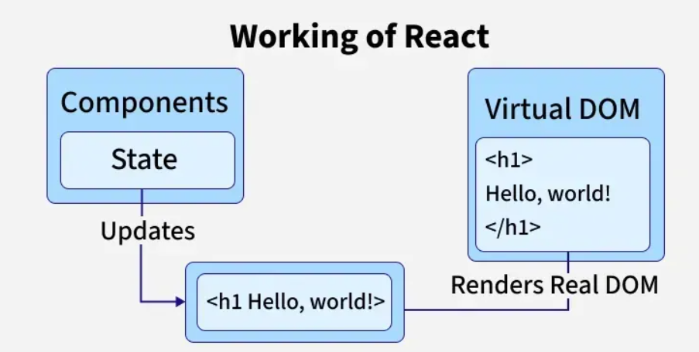
- Components: UI is broken into reusable, independent pieces.
- JSX: Allows writing HTML-like code inside JavaScript for easier UI development..
- Virtual DOM: A lightweight copy of the real DOM that tracks changes.
- Reconciliation: Compares old and new Virtual DOM and updates only the changed parts in the real DOM.
- One-way Data Flow: Ensures predictable UI updates by passing data from parent to child via props.
- State Management: React automatically re-renders components when their state changes.

55. What is JSX and how is it converted into JavaScript?
- JSX: Syntax extension for JavaScript, mainly used with React.
- HTML in JS: Allows writing HTML-like code inside JavaScript for easier readability and maintenance.
- Expressions: Embed JavaScript expressions in JSX using {}.
Example: The name written in curly braces { } signifies JSX
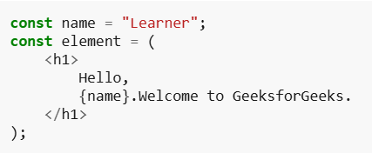
Browsers can’t understand JSX directly. Instead, tools like Babel transpile it into plain JavaScript using React.createElement().
const element = <h1>Hello, Geeks!</h1>;
Babel converts it into:
const element = React.createElement("h1", null, "Hello, World!");

56. What is a React component?
A Component is one of the core building blocks of React. In other words, we can say that every application you will develop in React will be made up of pieces called components. Components make the task of building UIs much easier.
- In React, we mainly have two types of components:
- Functional Components: Functional components are simply JavaScript functions. Initially, they were limited in terms of features like state and lifecycle methods. However, with the introduction of Hooks, functional components can now use state, manage side effects, and access other features that were once exclusive to class components.
- Class Components: Class components are more complex than functional components. They are able to manage state, handle lifecycle methods, and can also interact with other components. Class components can pass data between each other via props, similar to functional components.

57. Difference between functional and class component in React?
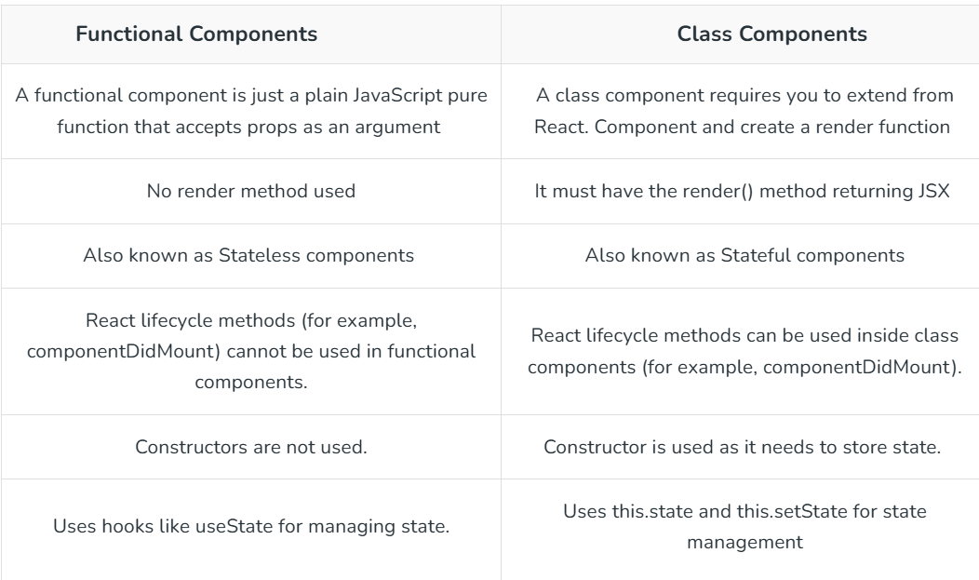
58. What are props and default props in React?
React allows us to pass information to a Component using something called props (which stands for properties). Props are objects which can be used inside a component. We can access any props inside from the component’s class to which the props is passed. The props can be accessed as shown below:
this.props.propName;
Default props are fallback values assigned to a component’s props when the parent does not provide them. They help prevent undefined errors and make components more robust. Default props can be defined using:
- Class components: ComponentName.defaultProps = { propName: defaultValue }
- Functional components: Assigning default values in function parameters.

59. What is state in React and how do you update it?
State is the internal, mutable data of a React component that controls its behavior and rendering. When state changes, React re-renders the component to update the UI.
State is updated using setState() in class components or the useState setter function in functional components. Updates are asynchronous and can be triggered by events, user interactions, or API responses. When new state depends on the previous state, the functional form (setState(prev => ...)) should be used.

60. Difference Between Props and State in React?
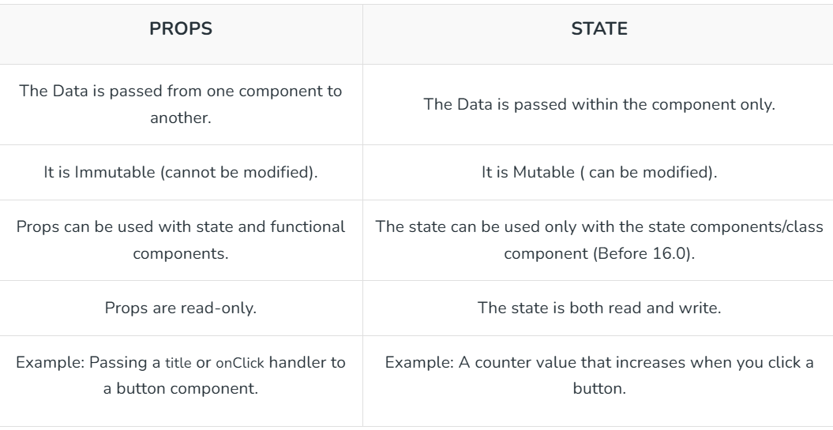

61. What are fragments in React?
In React, fragments allow you to group multiple elements without adding extra nodes to the DOM. Normally, returning multiple elements requires a wrapper like a <div>, which can create unnecessary DOM elements. Fragments solve this by letting you return multiple elements without extra wrappers.
- Fragments avoid extra DOM nodes.
- Short syntax: <> </> (cannot use attributes).
- Full syntax: <React.Fragment> </React.Fragment> (can use key).
- Useful in lists, tables, and grouping multiple elements.
- Helps keep the DOM clean and lightweight.

62. What is the difference between ReactDOM and React?
ReactDOM is a separate package that bridges React’s Virtual DOM with the browser’s real DOM. It provides methods to render, update, and remove React components in the DOM.
- Rendering Components: ReactDOM.createRoot and root.render mount components to a DOM node.
- Updating the DOM: ReactDOM applies Virtual DOM changes to the real DOM efficiently.
- Unmounting: ReactDOM.unmountComponentAtNode removes components from the DOM.
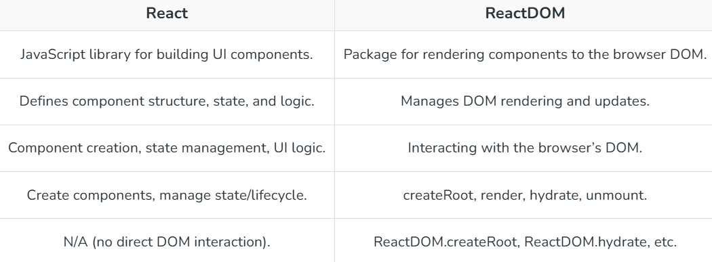
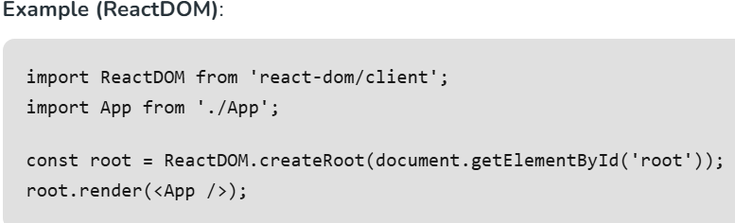
- React handles component logic; ReactDOM handles DOM integration.
- React 18 introduced createRoot for concurrent rendering, replacing ReactDOM.render.

63. What is Conditional Rendering in React?
Conditional rendering in React involves dynamically displaying components or elements based on conditions like state, props, or API responses. It’s essential for creating responsive UIs tailored to user interactions or data.
Use Cases:
- Show/hide elements based on authentication status.
- Display different layouts for user roles.
- Render loading spinners during data fetching.
- Conditionally show UI based on API responses.
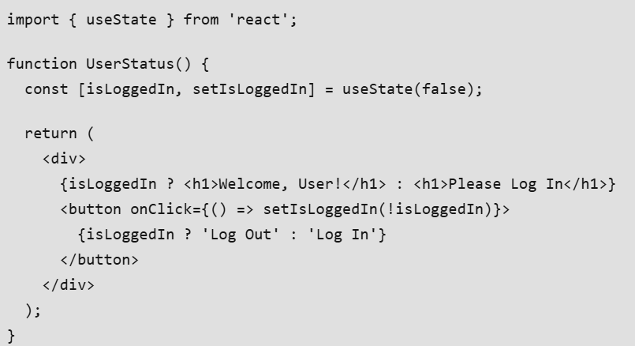
- Use ternary operators or logical && for concise rendering.
- Move complex logic outside JSX for readability.
- Avoid over-nesting conditions to maintain clarity.

64. What is the use of CSS Modules in React?
CSS Modules scope styles locally to a component, preventing style conflicts in large applications. They generate unique class names at build time, ensuring styles apply only to the intended component.
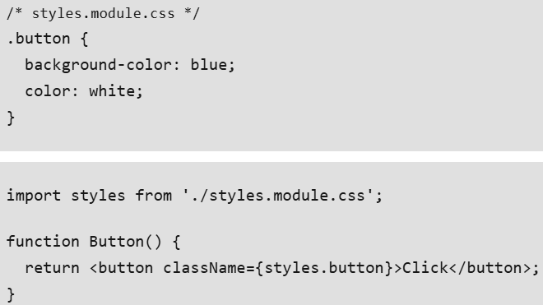
- CSS Modules are enabled in Create React App by default with .module.css files.
- Use camelCase for class names in JavaScript (e.g., styles.myButton).
- Alternatives include styled-components or Tailwind CSS.

65. Write a program to create a counter with increment and decrement?
This program demonstrates a simple counter using the useState hook to manage state and event handlers for incrementing and decrementing the count. The UI updates automatically when the state changes.
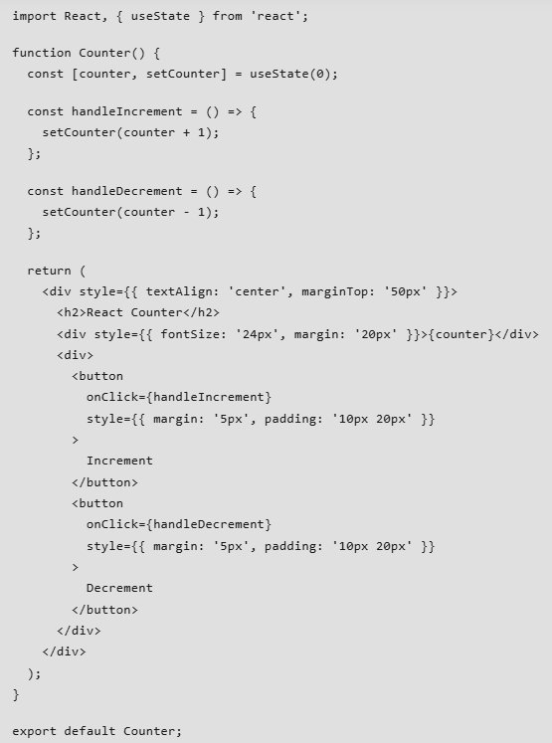
How It Works:
- useState initializes counter to 0 and provides setCounter to update it.
- handleIncrement increases the counter by calling setCounter(counter + 1).
- handleDecrement decreases the counter by calling setCounter(counter - 1).
- The UI displays the current counter value and updates on button clicks.
Points:
- Use descriptive handler names (e.g., handleIncrement) for clarity.
- Inline styles are used here for simplicity; prefer CSS Modules or styled-components in production.
- Ensure state updates are immutable to avoid bugs.

66. What are Hooks in React and why were they introduced?
Hooks are special functions in React that let you use state, lifecycle methods, and other React features in functional components, which were previously only available in class components.
Why introduced:
Before hooks, state and lifecycle methods could only be used in class components, leading to more boilerplate code and complex patterns.
Hooks allow simpler, cleaner code using functional components.
They promote reusability and composition of logic between components.
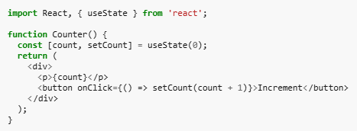

67. How does the useState hook work?
The useState hook allows you to add state to functional components. It returns a state variable and a setter function to update that state. When the state changes, React re-renders the component with the updated value.
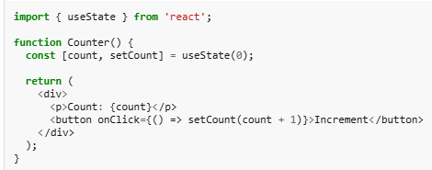
- count is the current state value.
- setCount is the function used to update state.
- 0 is the initial value when the component mounts. When setCount is called, React re-renders Counter with the new count value.

68. What are the rules of hooks and why are they important?
Hooks in React must follow certain rules to work correctly. These rules ensure that React can track state and effects reliably and prevent unexpected bugs.
- Always call hooks at the top level of your component or custom hook.
- Only call hooks from React functional components or custom hooks.
- Custom hooks should always start with use, like useFetch or useForm.
Why they are important:
- Preserve state and effect order between renders.
- Ensure components behave predictably.
- Prevent bugs and unexpected behavior when using hooks like useState and useEffect.

69. Can you explain what the Virtual DOM is and how React uses it?
The Virtual DOM (VDOM) is a lightweight, in-memory representation of the real DOM in the browser. Instead of updating the actual DOM directly, which can be slow and costly, React first updates the Virtual DOM when a component’s state or props change. React then compares the new Virtual DOM with the previous one using a process called diffing, identifies the minimum set of changes needed, and updates only those parts of the real DOM. This approach makes UI updates faster and more efficient by reducing unnecessary DOM manipulations. Key points:
- Virtual DOM is a JavaScript object representing the real DOM.
- React updates the VDOM first, not the real DOM.
- Uses a diffing algorithm to detect changes efficiently.
- Only the necessary parts of the real DOM are updated.
- Improves performance and user experience in dynamic applications.

70. How do you render a list of items in React?
In React, lists are usually rendered using JavaScript’s .map() method. Each list item should also have a unique key prop so React can efficiently track and update elements.
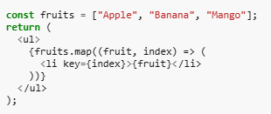
In this Example, .map() is used to iterate over the array, and the key prop helps React identify each list item uniquely.

71. Why is the key prop important in React lists?
The key prop is important because it helps React efficiently manage list rendering. It allows React to identify which items have changed, been added, or removed, instead of re-rendering the entire list.
- Helps React track elements and update only what’s necessary.
- Prevents unnecessary re-renders, improving performance.
- Best practice: Use a unique ID as the key instead of the array index whenever possible.

72. What happens if we use the array index as a key in React?
Using the array index as a key technically works, but it is not recommended in most cases. If the list changes (items are reordered, added, or removed), React may reuse components incorrectly, leading to UI bugs.
- Can cause issues when list items are reordered.
- May lead to incorrect updates if items are added or removed.
- Safe only for static lists that never change.

73. What is the difference between rendering lists with map() vs forEach()?
When rendering lists, it’s important to return JSX elements for each item. The choice between map() and forEach() affects this:
- map(): Returns a new array, which can contain JSX elements to be rendered. This is the preferred method for rendering lists in React.
- forEach(): Does not return a new array, so it cannot directly produce elements for rendering. It’s only useful for side effects.
Example using map():
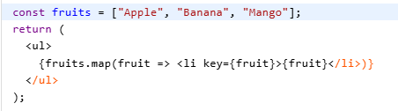
- map returns an array of <li> elements, which React renders.
- Using forEach here would not work, because it does not return the array of elements.

74. How are forms handled in React compared to plain HTML?
In plain HTML, the browser’s DOM manages form data. In React, form inputs are usually controlled components:
- The form values live in state.
- Each keystroke triggers an onChange handler to update state.
- This makes the data predictable and easy to validate before submission.
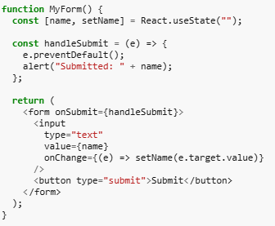
In this example, the input is fully controlled by React through value and onChange.

75.How do you prevent the default form submission behavior in React?
By using event.preventDefault() inside the form’s onSubmit handler.
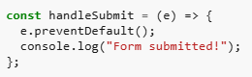
In this example, the page is stopped from reloading and lets React control what happens on submit.

76. Explain the types of routers in React?
React Router provides three types of routers for handling navigation in React applications, each suited for different use cases.
Types of Routers:
1. BrowserRouter: Uses HTML5 history API (pushState, replaceState, popState) to manage URLs, providing clean URLs (e.g., /about). Ideal for web applications with server support.
import { BrowserRouter } from 'react-router-dom';
2. HashRouter: Uses the hash portion of the URL (e.g., /#about) for routing. Suitable for static sites or environments without server-side routing.
import { HashRouter } from 'react-router-dom';
3. MemoryRouter: Stores URL history in memory, not in the browser. Useful for testing or non-browser environments like React Native.
import { MemoryRouter } from 'react-router-dom';
- BrowserRouter is the most common for modern web apps.
- HashRouter is simpler for static hosting but less SEO-friendly.
- MemoryRouter is rare, primarily for non-browser contexts.

77. What is React Router and why is it used?
React Router is a library that enables client-side routing in React applications. It allows you to create single-page applications (SPAs) where navigation between views happens without a full page reload, making apps faster and smoother.

78. Difference between <a> tag and <Link> in React Router?
- <a> tag: Reloads the whole page when navigating.
- <Link> component: Updates the URL and changes the component without reloading (SPA behavior).

79. What are the main components of React Router?
- <BrowserRouter> – Wraps the app and enables routing.
- <Routes> – Container for all route definitions.
- <Route> – Defines a path and the component to render.
- <Link> / <NavLink> – For navigation.
- useNavigate() – For programmatic navigation.

80. What is Redux?
Redux is a popular open-source state management library for JavaScript applications. It provides a way to centralize the state of an application in a single store, making it easier to debug, test, and reason about the state changes in the application.

81. Explain the core principles of Redux.
Three principles that Redux follows are:
- Redux is a Single Source of Truth
- The State is Reada only State
- The Modifications are Done with Pure Functions

82. What is the difference between Redux and Context API.
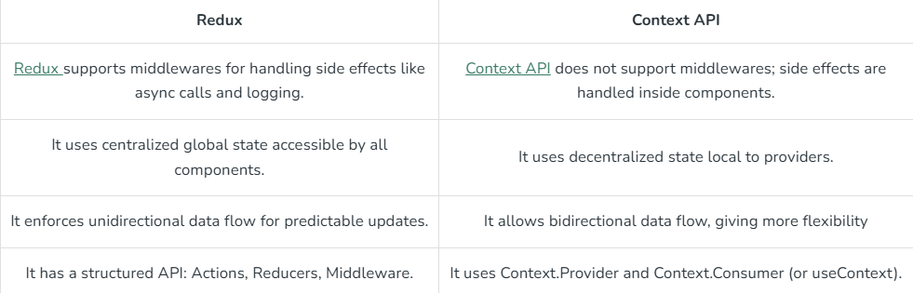

83. What are pure functions in the context of Redux?
A pure function is defined as any function that doesn't alter input data, doesn't depend on the external state, and can consistently provide the same output for the same input. As opposed to React, Redux depends on such pure functions.

84. What are the key components of Redux architecture?
In Redux, actions describe what happened, reducers define how state changes, and the store holds the application’s state.
- Actions: Actions in Redux are plain JavaScript objects that provide information to the store, with a required type field and optional data fields for additional information.
- Reducers: Reducers are the pure functions that take the current state and action and return the new state and tell the store how to do.
- Store: The store is the object which holds the state of the application.

85. What is the purpose of the Redux store?
The Redux store is a centralized object that holds the state of the application. It allows components to access and update the state using dispatch and selectors. The state inside the store can only be modified by dispatching actions.
Functions:
- createStore(reducer): Creates a Redux store using a reducer function.
- dispatch(action): Sends an action to the store to update the state.
- getState(): Retrieves the current state of the store.

86. What is the purpose of the Provider component in React Redux?
The Provider component in React Redux makes the Redux store accessible to all nested components, allowing them to connect and use the store throughout the app.
- The Provider component makes the Redux store available to any nested components that need to access the Redux store.
- Since any React component in a React Redux app can be connected to the store, most applications will render a <Provider> at the top level, with the entire app's component tree inside of it.

87. What is the connect function in React Redux used for?
The connect() function in React Redux links a React component to the Redux store, providing it access to state data and dispatch functions to update the store.
- The connect() function connects a React component to a Redux store.
- It provides its connected component with the pieces of the data it needs from the store, and the functions it can use to dispatch actions to the store.

88. What is the purpose of the dispatch function in React Redux?
The dispatch function is mainly used for dispatching actions to the Redux store. It is a method provided by the Redux store that accepts an action object as its argument and triggers the state update process.

89. What are the two types of React components?
The two types of React components are class components and functional components.

Class components: These are ES6 classes that extend the React.Component class. They have a render() method where you define what should be rendered to the DOM. Class components can manage their own state using setState() and have access to lifecycle methods such as componentDidMount() and componentDidUpdate().
Syntax:
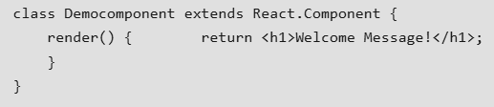
Functional components: These are simple JavaScript functions that return JSX (a syntax extension for JavaScript used with React). They are also known as stateless functional components or just functional components.
Syntax:
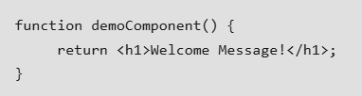

90. How do you create a class component in React?
To create a class component in React, you typically define a JavaScript class that extends the React.Component class.
1. Import React:
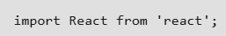
2. Define your class component:
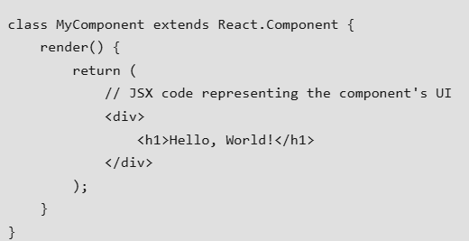
3. Export your component:


91. How do you create a functional component in React?
To create a functional component in React, you simply define a JavaScript function that returns JSX .
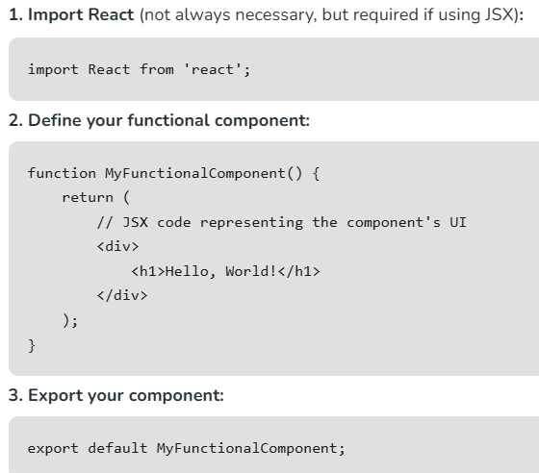

92. What is the purpose of the render() method in a class component?
The render() method in a class component is a fundamental part of React's component lifecycle. Its purpose is to define what should be rendered to the DOM when the component is rendered or updated.
- Returning JSX: The primary purpose of the render() method is to return JSX that represents the UI of the component.
- Component Re-rendering: Whenever the state or props of a component change, React will automatically call the render() method again to re-render the component and update the DOM with any changes.
- Virtual DOM: React uses a virtual DOM to efficiently update the actual DOM. The render() method generates a virtual DOM representation of the component's UI.

93. How do you render a React component on the DOM?
To render a React component on the DOM, you typically use the ReactDOM.render() method.
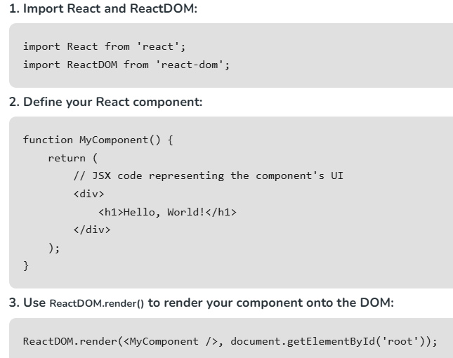

94. What is JSX? How does it differ from HTML?
JSX stands for JavaScript XML. It is a syntax extension for JavaScript, often used with React to describe what the UI should look like. JSX may remind you of a template language, but it comes with the full power of JavaScript.
Difference between JSX and HTML
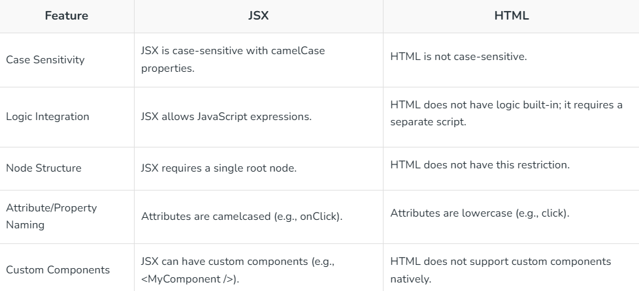

95. How can you pass props to a React component?
You can pass props to a React component by adding attributes to the component when you use it in JSX.
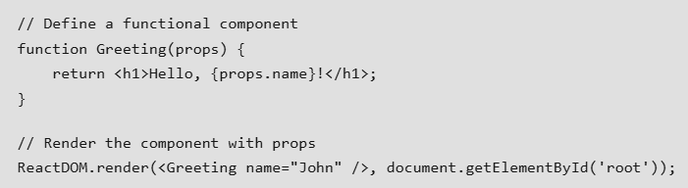

96. How do you initialize state in a class component?
In a class component in React, you initialize state in the constructor method.
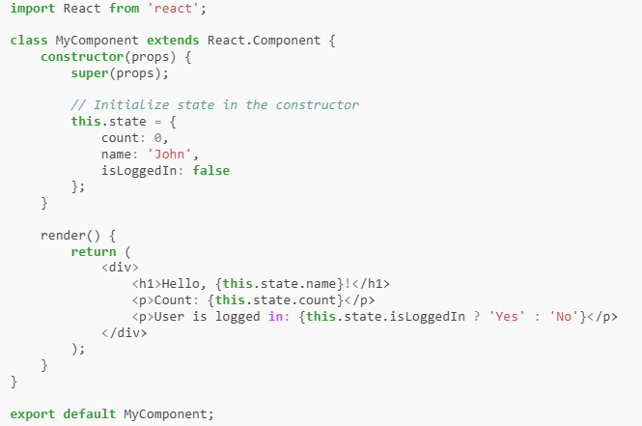

97. What is the purpose of the setState() method?
The setState() method in React is used to update the state of a component, triggering a re-render with the updated state. It manages state changes asynchronously that allows React to batch multiple updates for performance optimization. When calling setState(), React merges the provided state updates with the current state, updating only the specified properties.

98. How do you handle events in React?
In React, you handle events using JSX by passing event handler functions as props to React elements.
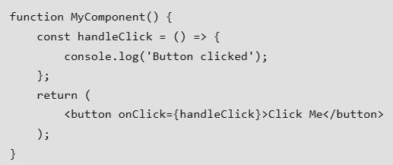

99. How do you conditionally render elements in React?
In React, you can conditionally render elements by using JavaScript expressions inside JSX.
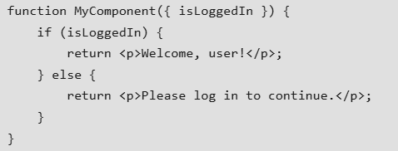

100. What is the purpose of the && operator in JSX?
The purpose of the && operator in JSX is to conditionally render elements based on a boolean expression. It allows you to render an element only if the expression evaluates to true, and if it evaluates to false, it will not render anything.
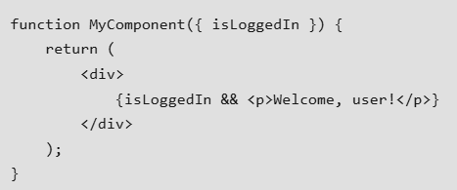

101. How do you use the ternary operator for conditional rendering in React?
In React, you can use the ternary operator (condition ? trueValue : falseValue) for conditional rendering. This allows you to render different JSX elements based on a condition.
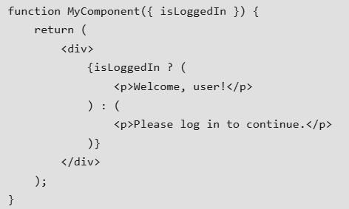

102. What are the different ways to style React components?
There are various way by which we can style our react components:
- Inline CSS: In inline styling basically, we create objects of style. And render it inside the components in style attribute using the React technique to incorporate JavaScript variable inside the JSX (Using ‘{ }’ )
- Styled Components: The styled-components allows us to style the CSS under the variable created in JavaScript. styled-components allow us to create custom reusable components which can be less of a hassle to maintain.
- CSS Modules: A CSS module is a simple CSS file but a key difference is by default when it is imported every class name and animation inside the CSS module is scoped locally to the component that is importing it also CSS file name should follow the format ‘filename.module.css’.

103. What is React Hooks?
React Hooks is a function that lets us use state and other React features without writing a class. They were introduced in React 16.8 to enable functional components to use state which means to make the code good and easy to understand.
React hooks are functions that enable functional components to use state and lifecycle features that were previously only available in class components. Hooks provide functions like useState, useEffect, useContext, etc., that allow we to "hook into" React features from functional components.

104. What are the basic built-in React Hooks?
The basic built-in React Hooks are useState, useEffect, useContext, useReducer, useCallback, useMomo, useRef and useImperativeHandle.
- useState enables components to manage and update their own state without using classes.
- useEffect is used to connect components to an external system.
- useContext it is used to consume data from a Context in a functional component.
- useReducer is used to manage complex state logic through a reducer function.
- useCallback used to memoize functions, preventing unnecessary re-renders in child components.
- useMemo is used to memoize the result of a function computation, preventing unnecessary recalculations.
- useRef is used to create mutable references that persist across renders in functional components.
- useImperativeHandler customizes the instance value that is exposed when using ref with functional components.

105. What is React Router?
React Router is a standard library for routing in React. It enables the navigation among views of various components in a React Application, allows changing the browser URL, and keeps the UI in sync with the URL.

106. How do you install React Router?
You can install React Router using npm or yarn:

Using npm
npm install react-router-dom
Using Yarn
yarn add react-router-dom

107. What are the benefits of using React Router?
- Declarative Routing: React Router provides a declarative way to define routing in your application using JSX syntax. This makes it easy to understand and maintain the routing configuration of your application.
- Dynamic Routing: React Router supports dynamic routing, that allows you to define routes with parameters that can change based on user input or application state. This makes it easy to create dynamic and data-driven UIs.
- Code Splitting: React Router supports code splitting that allows you to split your application into smaller chunks that are loaded on demand.
- History Management: React Router provides a history API that allows you to programmatically navigate between different pages in your application, as well as manage browser history (e.g., go back, go forward).
- Server-Side Rendering: React Router is compatible with server-side rendering (SSR) frameworks like Next.js, allowing you to render React components on the server and send the fully rendered HTML to the client. This can improve SEO and initial load performance.

108. Explain the Route component in React Router.
The Route component in React Router is a fundamental element used to define routes in React applications, and helps in the rendering of specific components based on the current URL. It takes props like "path" to specify the URL pattern. With Route, you can create dynamic and declarative routing structures for efficient navigation and rendering of components.

109. How do you create a route with a parameter in React Router?
You can create a route with a parameter using the :paramName syntax, for example:
<Route path ="/users/:userId" component ={UserComponent}/>

110. Explain the difference between Link and NavLink in React Router.
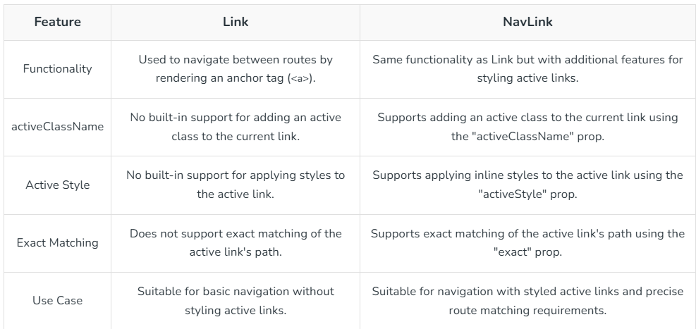

111. Is it necessary to keep all the component states in the Redux store?
No, not all component states need to be in Redux; it’s best used for shared or global state, while local state can remain within components.
- While Redux provides a centralized state management solution, it's not meant to replace local component state entirely.
- There are several factors to consider when deciding whether to use Redux for a particular piece of state.

112. What is the significance of immutability in Redux?
Immutability in Redux ensures predictable state updates and simplifies management, allowing efficient change detection, better performance, and easier debugging.

- Allows quick detection of state changes without deep comparison.
- Ensures consistent and predictable updates across the application.

113. What do you understand about Redux Toolkit?
Redux Toolkit is an npm package that simplifies Redux by providing an easy, flexible, and powerful way to create and manage stores, especially for large applications.
- Redux toolkit is a npm package that is made to simplify the creation of redux store and provide easy state management.
- Before the introduction of the Redux toolkit state management was complex in simple redux.
- The Redux toolkit acts as a wrapper around redux and encapsulates its necessary functions.
- Redux toolkit is flexible and provides a simple way to make a store for large applications.
- It follows SOPE principle which means it is simple, Opinionated, Powerful, and Effective.

114. What’s the typical flow of data like in a React with Redux app ?
- User Interaction: Triggers an action in the component.
- Action Dispatch: The action is sent to the Redux store.
- Reducers Update State: The root reducer processes the action, updating the state by returning a new copy.
- Store Updates Components: The store notifies subscribed components, which then re-render with the new state.
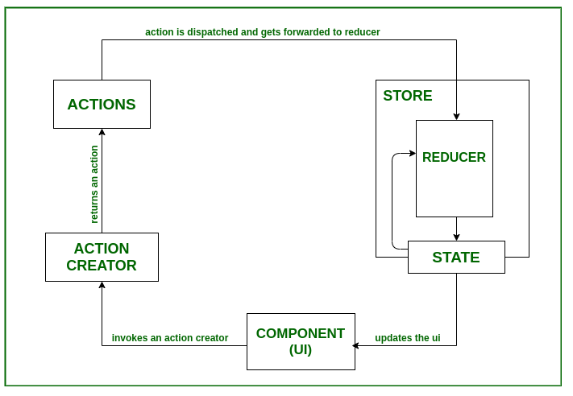

115. Explain the mapStateToProps functions in React Redux.
In React Redux, mapStateToProps maps parts of the Redux state to a component’s props, allowing the component to access and use the required state data.
- In React Redux, the mapStateToProps function is used to connect Redux state to React component props.
- It's a function that maps parts of the Redux state to the props of a React component, and allows the component to access and use that state.

116. Explain mapDispatchToProps functions in React Redux.
In React Redux, mapDispatchToProps maps action creators to a component’s props, enabling the component to dispatch actions to the store without directly accessing it.
- The mapDispatchToProps function is used to map Redux action creators to component props.
- It allows components to dispatch actions to the Redux store without directly accessing the store or importing action creators.

117. What is Redux middleware?
Redux middleware is software that sits between action creators and reducers, intercepting actions to handle async tasks, modify actions, or add custom behavior before they reach the reducers.
- Redux middleware is a piece of software that works between the action creators and the reducers in a Redux application.
- It intercepts actions before they reach the reducers, and allows to perform asynchronous operations, modify actions, or implement custom behavior.

118. What is the difference between synchronous and asynchronous middleware in Redux?
Synchronous middleware in Redux handles actions immediately, while asynchronous middleware manages actions that involve delayed or async operations.
- Synchronous: executes actions instantly.
- Asynchronous: handles delayed or async tasks.
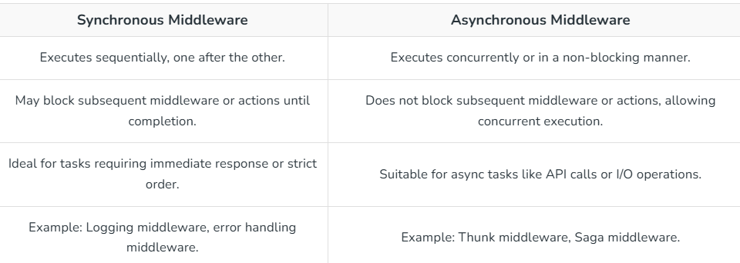

119. Explain the purpose of the redux-thunk middleware.
Redux-Thunk middleware allows action creators to return functions instead of plain objects, enabling Redux to handle asynchronous logic and access the store’s dispatch and state.
- The purpose of the redux-thunk middleware is to enable Redux to handle asynchronous logic more easily, particularly when dealing with actions that don't immediately return an object, but instead return a function.
- Redux-thunk extends Redux functionality by allowing action creators to return functions instead of plain action objects.
- These functions, known as thinks and have access to the dispatch and getState functions of the Redux store.

120. Explain the concept of "single source of truth" in Redux?
In Redux, "Single Source of Truth" means that the entire application state is stored in a single central store, represented as an object tree. This ensures consistency, easy debugging, and predictable state management.
- Easier State Management: All components access state from a single source, reducing inconsistencies.
- Simplifies Debugging & DevTools: The state can be easily inspected and time-traveled (e.g., Undo/Redo).
- Universal (Isomorphic) Apps: The state can be serialized and transferred between the server and client.
- Predictable Updates: State changes occur only through dispatched actions, making the flow easier to track.

121. What are selectors in Redux?
Selectors in Redux are functions that extract and transform specific pieces of state, making data access efficient, reusable, and easier to manage across components.
- Encapsulate state access and transformation.
- Promote reuse across multiple components.

122. Explain the concept of "container components" in React Redux.
Container components in React Redux connect to the store and act as a bridge, supplying presentational components with state data and dispatchable actions.
- Container components are React components that are responsible for interacting with the Redux store.
- They are connected to the Redux store using the connect() function.
- Container components acts as the bridge between the Redux store and presentational components, providing them with the necessary data from the store and actions to dispatch.

123. What are lifecycle methods in React?
Every React Component has a lifecycle of its own, lifecycle of a component can be defined as the series of methods that are invoked in different stages of the component’s existence. A React Component can go through four stages.

124. Explain the lifecycle phases of a class component.
Class Component can go through stages of its life as follows.
Mounting Phase:
- constructor(): Initialize state and bind event handlers.
- render(): Render UI based on state and props.
- componentDidMount(): Perform side effects after the component is rendered.
Updating Phase:
- render(): Re-render UI based on state or prop changes.
- componentDidUpdate(): Perform side effects after re-rendering.
Unmounting Phase:
- componentWillUnmount(): Clean up resources before the component is removed from the DOM.
Error Handling:
- componentDidCatch(): Handle errors during rendering or in lifecycle methods of child components.

125. What is the purpose of the componentDidMount() method?
Purpose of componentDidMount lifecycle method
- Initialization: componentDidMount is a crucial lifecycle method in React that gets invoked after a component has been successfully inserted into the DOM (Document Object Model).
- Asynchronous Operations: It is particularly useful for handling asynchronous operations such as data fetching.
- Interacting with the DOM: If your component needs to interact directly with the DOM or other JavaScript frameworks, componentDidMount is the appropriate stage for such operations.
- Integration with External Libraries: When integrating React with external libraries or non-React code, componentDidMount allows you to safely initiate these integrations.

126. What is the purpose of the componentWillUnmount() method?
Purpose of the componentWillUnmount() method:
- Cleanup Tasks: componentWillUnmount() is commonly used to perform cleanup tasks such as removing event listeners, canceling network requests, or unsubscribing from external data sources.
- Release Resources: componentWillUnmount() provides a hook to release resources which are no longer needed and ensure that they are properly cleaned up before the component is removed from the DOM.
- Prevent Memory Leaks: componentWillUnmount() allows you to release resources and unsubscribe from external data sources, preventing memory leaks and ensuring that resources are properly managed throughout the component's lifecycle.

127. What is component composition in React?
Component composition in React is used for building complex user interfaces by combining smaller, reusable components together. This helps breaking down the UI into smaller, more manageable pieces, each responsible for specific functionality or UI elements. By combining these components hierarchically and passing data and behavior through props, you can create scalable, maintainable, and customizable UIs.

128. What are higher-order components (HOCs) in React?
Higher-order components or HOC is the advanced method of reusing the component functionality logic. It simply takes the original component and returns the enhanced component.
Syntax:
const EnhancedComponent = higherOrderComponent(OriginalComponent);
Reason to use Higher-Order component:
- Easy to handle
- Get rid of copying the same logic in every component
- Makes code more readable

129. What are error boundaries in React?
Error boundaries are a React component that catches JavaScript errors anywhere in their child component tree, log those errors, and display a fallback UI instead of crashing the entire component tree. They are used to ensure that errors in one part of the UI don't affect the rest of the application.

130. What are some ways to optimize the performance of React components?
We can perform some actions and precautions to optimize the performance.
- Use binding functions in constructors: By adding an arrow function in a class, we add it as an object and not as the prototype property of the class. The most reliable way to use functions is to bind them with the constructor.
- Avoid inline style attributes: The browser often invests a lot of time rendering, when styles are implied inline. Creating a separate style.js file and importing it into the component is a faster method.
- Avoid bundling all of the front end code in a single file: By splitting the files into resource and on-demand code files we can reduce the time consumed in presenting bundled files to the browser transformers.
- Avoid inline function in the render method: If we use the inline function, the function will generate a new instance of the object in every render and there will be multiple instances of these functions which will lead to consuming more time in garbage collection.

131. What is memoization in React?
Memoization in React is the process of optimizing functional components by caching the result of expensive computations and reusing it when the component is re-rendered with the same props. This technique helps to avoid unnecessary re-computation of values, thereby improving performance by reducing the workload on the rendering process.

132. What is code-splitting in React?
Code-splitting in React is a technique used to improve the performance of web applications by splitting the JavaScript bundle into smaller chunks, which are loaded asynchronously at runtime. This allows the browser to download only the necessary code for the current view, reducing the initial load time and improving the overall performance of the application.

133. What problems do React Hooks solve?
React Hooks solves the problems of sharing the stateful logic between components in a more modular and reusable way than class components.

134. What is the purpose of useCallback Hooks?
The purpose of useCallback Hooks is used to memoize functions, and prevent unnecessary re-rendering of child components that rely on those components. The useCallback function in React is mainly used to keep a reference to a function constant across multiple re-renders. This feature becomes useful when we want to prevent the unnecessary re-creation of functions, especially when we need to pass them as dependencies to other hooks such as useMemo or useEffect.

135. How does useReducer differ from useState?
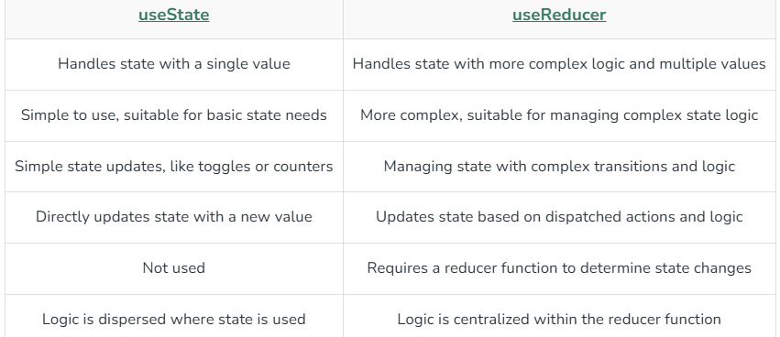

136. Explain the purpose of useLayoutEffect?
The useLayoutEffect is similar to useEffect but fires synchronously after all DOM mutations. It's useful for reading from the DOM or performing animations before the browser paints. Due to its synchronous nature, excessive usage of useLayoutEffect may potentially impact performance, especially if the logic within it is computationally intensive or blocking. It's essential to use useLayoutEffect judiciously and consider performance implications carefully.

137. What is Custom Hooks?
Custom hooks in React are like wer own personal tools that we can create to make building components easier. They're functions we write to do specific tasks, and then we can reuse them in different components. They're handy because they let we keep were code organized and share logic between different parts of wer application without repeating werself.

138. Can custom Hooks accept parameters?
Yes, custom hooks in React can indeed accept parameters. By accepting parameters, custom hooks become more flexible and can adapt their behavior based on the specific needs of different components.
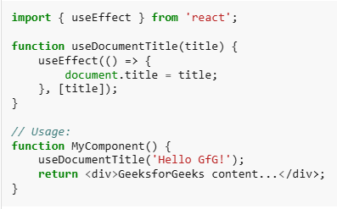

139. What happens if we omit dependencies in the dependency array of useEffect?
If we omit dependencies in the dependency array of useEffect, the effect will run after every render. This means that the effect will be executed on the initial render and after every subsequent re-render, regardless of whether any specific values have changed.
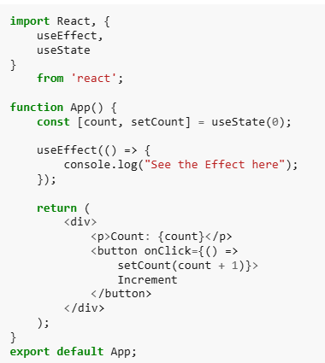

140. What is the purpose of the second argument in useState?
The purpose of the second argument in useState is to initialize the state value. When we call useState(initialValue), the initialValue provided as the second argument is used to initialize the state variable.
const [count, setCount] = useState(0);
In this '0' is the initial value provided as the second argument to useState, so count will be initialized with '0' as its initial value.

141. Explain the concept of lazy initialization with useState?
Lazy initialization with useState allows we to initialize state lazily based on a function, which is only called on the initial render. The concept of lazy initialization with useState in React allows we to initialize state lazily, i.e., on-demand when it's needed, rather than eagerly during component initialization. This means that we can compute the initial state dynamically based on some conditions or heavy computations.

142. Can we use Hooks in class components?
No, we cannot use hooks in class components directly. Hooks are a feature introduced in React 16.8 to allow stateful logic to be used in functional components. They cannot be used in class components because hooks rely on the functional component's call order to manage state and lifecycle behaviors, which is not compatible with the class component's lifecycle methods.

143. Can we use React Router with server-side rendering?
Yes, React Router can be used with server-side rendering (SSR). While React Router primarily handles client-side routing, it is compatible with server-side rendering frameworks like Next.js that allows you to render React components on the server and send the fully rendered HTML to the client.

144. What is nested routing?
Nested routing refers to defining routes within other routes in a hierarchical manner. This is commonly used in frameworks like React Router or Next.js to organize and manage complex application structures. Nested routing is particularly useful for applications with multiple layers of content or sections that require their own routing logic.

145. What are the differences between react-router-dom and react-router-native?
